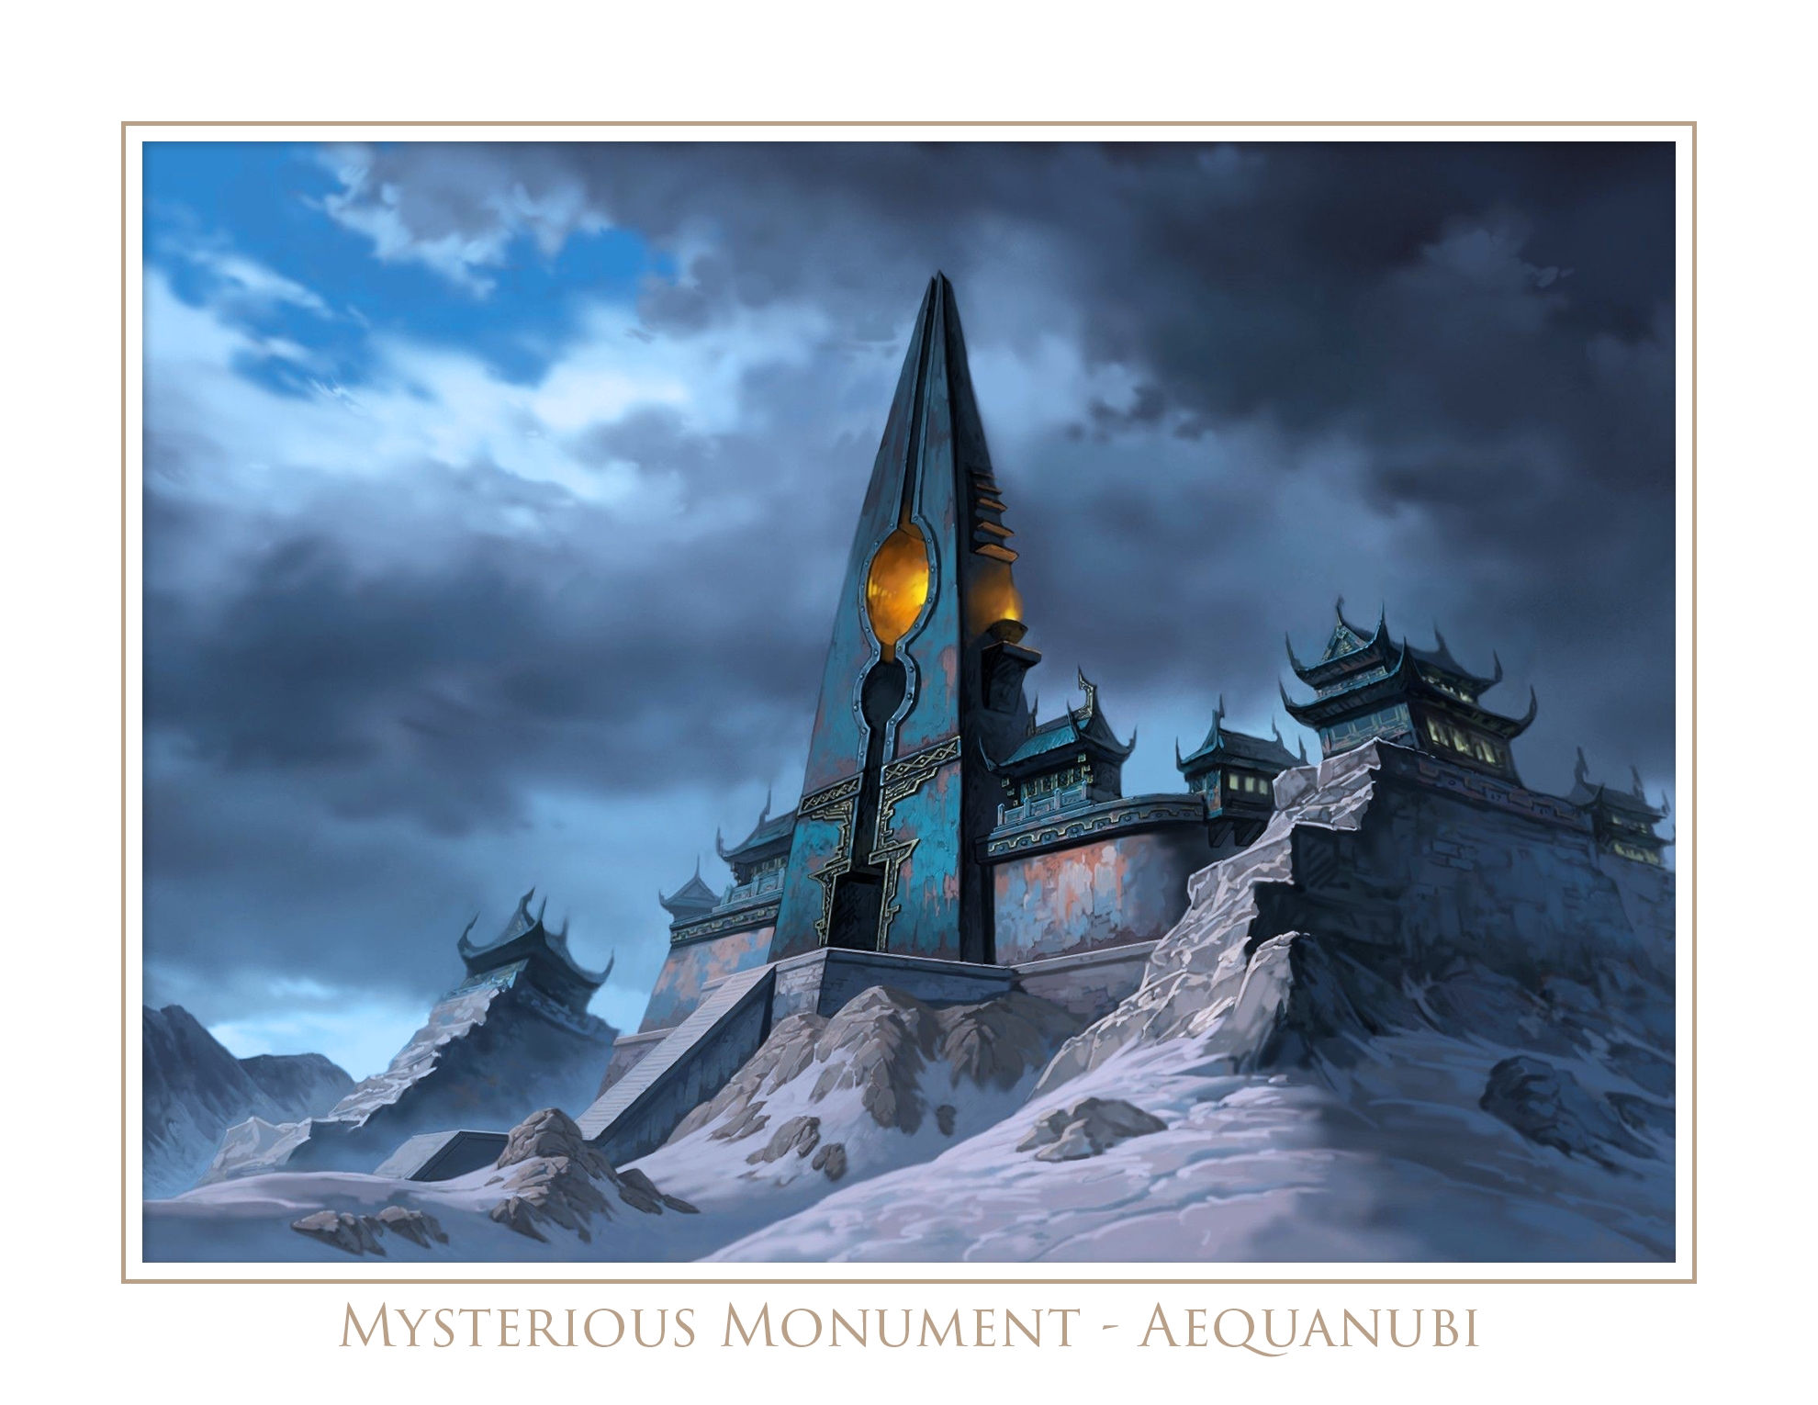

Northern - Ignan

*“Twice in eternity and always within eyesight” Solution: T*

◻ Opened ◻Conquered

**1. Lava Moat**

The party enters a room that is 40’ wide and circular. There is a ledge that goes around the room and it is only 5’ wide. In the middle of the room is a 7’ circular ledge with a 20’ tall cylindrical pillar that is slightly smaller in width than the ledge it is currently on. It doesn’t appear the pillar is affixed to the ledge and is merely standing on top of it.

Surrounding the middle platform and sitting 7’ below the ledge is a pool of lava. It is not clear how deep the pool is. If the party is able to move all the lava in order to see the bottom of the pool, they will find a trap door that is unlocked, but requires a STR DC15 to open. The door drops to an opening just above the entrance to room 4 (Burning Skies), in the dungeon.

Jumping across the ledge or using a grappling hook to lasso around the pillar requires a DEX DC20 check, *but remind the player they can only jump half their STR number since there is no running head-start.*

When the party figures out how to pull the pillar off its seat and fall over, it’ll create a bridge between the ledge and the platform. It will also reveal a tunnel entrance into a stairwell that descends to the next room.

*Hint: All players get a 50’ piece of rope with their starting equipment, and so 3 of them tied together will be enough to circumvent the ledge going around the room. At this point they can pull the rope taut against the pillar from any direction and pull it off its pedestal.*

**2. Fiery Horn**

The room walls are covered with fresco paintings depicting children and ponies running through fire. They appear happy and laughing. In the middle of the room is a crude stone chair that was put together and brought in from the outside. There is a non-magical cloak draped in the seat. The cloak is dark red with a crystal blue silk trim, and the cloak is embossed with a flame pattern.

Along the ceiling is a slender and long brass horn that travels from all four corners of the room and meets at the middle just above the chair. In the four corners the mouthpieces of the horn falls down the wall to just at the middle, about 5’ up. The entire tubing of the horn is embossed with a flame pattern.

When the characters interpret that in their own way, do enough creative and cool shit, let them through.

**3. Backwards Corridor**

The party enters into a corridor that looks normal but ends in a dead end with a stone wall. There is no light in the room. When the party reaches the dead end and turns around there is a brick wall, essentially trapping them inside the corridor. The new brick wall has an inscription that reads “*Keep your eye on the wall.”* If they walk backwards while staring at the brick wall they will walk into the next room.

**4. Burning Skies**

The room enters into a very wide entrance, and then it narrows to a small 10’ width at the opposite end. In the middle of the room are six 3’ tall, circular stone pedestals with unlit braziers on top, standing in two rows with 3 on each side, left and right. At the far end there is a very beautiful iron door with an engraving depicting a battle scene with a woman holding a pitcher of some sort above what appears to be a hydra or a five headed serpent with rays of light streaming from above. The door has what appears to be claw marks that have scratched and torn at it from a powerful creature. Around the door on the stone wall are runic markings that seem to be written in the abyssal tongue. They read, *“To go forward, you must return. To glow brightly, the sky must burn!”*

When the characters interpret that in their own way, do enough creative and cool shit, let them through.

**5. Lava Bridge**

The entrance to the room is guarded by a yellow aura that rests on the threshold. It appears, sounds and even smells benign. As you enter the room and a sudden rush of heat pours through each party member’s body, and then it’s gone. All their equipment has been teleported to another location.

The room is a rectangular room, length wise, with a pool of lava just off the initial entrance platform. There are 4 stones that appear sturdy, and possibly the tops of pillars resting in the lava. Resting next to the entrance door are two wooden boards measuring 9’ each. Behind the boards is a musty and dirty Glove of Storing that contains one charge of a spell Greater Invisibility. *The glove is a red herring, useless for the puzzle.*

WIS DC15 will reveal that each stone has a very thin pressure plate on it, and when activated will slowly drop the entrance platform into the lava. When 4 pressure plates have been ticked, the entrance platform will be completely submerged in lava.

Each board can only support 1 party member on it when put between 2 stones, as a bridge. When the party reaches the other side, the door will exit out the entrance to the dungeon and the next portion of the map will be revealed.

✶

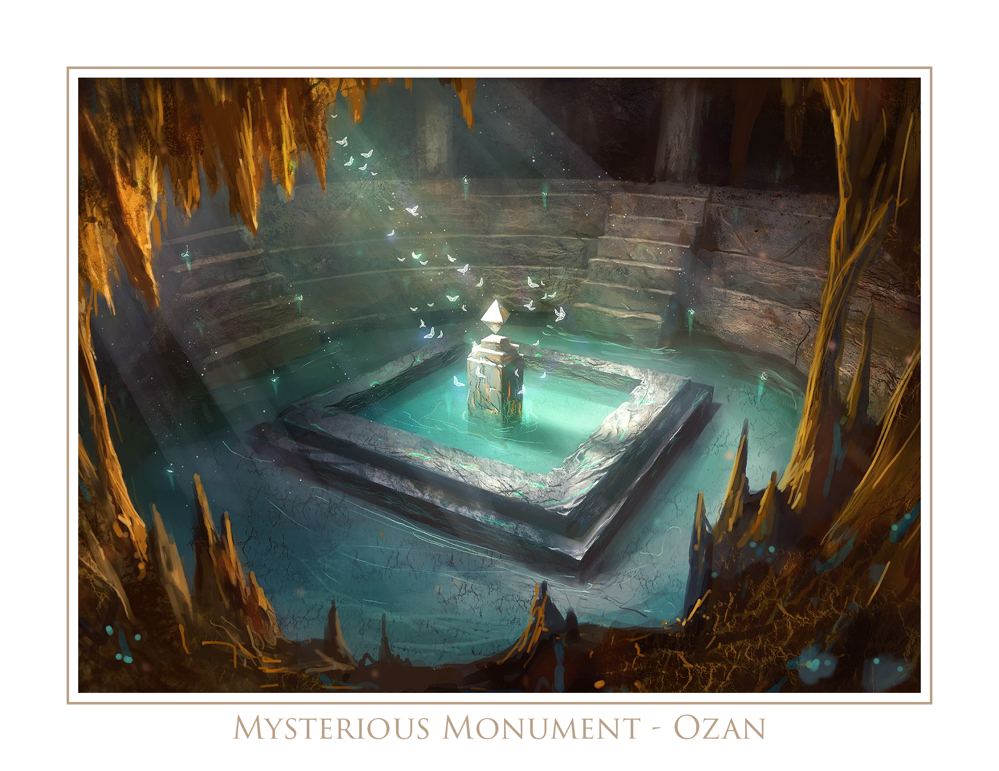

Central - Abyssal

*“Up and down they go and travel, but never do they move an inch.” Solution: Stairs*

◻ Opened ◻Conquered

**1. The Curse**

The entrance room is circular with carved faces in the stone wall. They all seem to be holding their faces and screaming. There is also a small door on the right side of the wall near the floor that looks like a small creature might fit inside. The door is locked. If broken, STR DC10, it will reveal a sack of owlbear feathers. There is a faint torch mounted on the entrance and exit doors. In the middle arranged in a triangle are three stones of different colors, red, blue and yellow. If the party attempts to exit the room from the far door they’ll find it to be blocked by an invisible barrier. There is an inscription on the wall that reads:

*“At my feet lies three stones to hold dear. The source of three gifts that no one should bear. The keepers of secrets, the guardians of exits. Let the guessing begin, because shit’s gonna’ get hectic.”*

When a character picks up a stone it becomes affixed to his hands, and he is imbued with a curse per below. When the characters are able to identify any other character’s curse in a mostly general sense that is obvious, that curse is lifted and their particular barrier is lifted from the exit doorway.

* Red - Cannot speak unless someone else is speaking. You are compelled to talk loudly over them.
* Blue - You cringe in pain whenever you speak or hear a word containing the letter S.
* Yellow - Every sentence must begin and end with a word that begins with the letter S.
* Green can speak only if no one else is speaking
* Violet – can speak in rhymes only
* Black – cringe in fear when someone speak in rhymes

**2. Rude Door**

A very small room that looks plainly, and almost as if someone had been in there recently. There is a small desk with a stack of aged parchment on top. There is also a bottle of ink with a quill sticking out of it. A chair with fox fur lined on the backing and the arms is seated underneath. There is a painting of a nature scene on the wall, a small table in the corner with a teapot and two tea cups. On the floor is a simple wolverine skin rug. From the ceiling is a plain candle lantern that is lit.

There is absolutely nothing of value in the room. When the characters try to open the exiting door it’ll swing outward and a silver gauntlet will pull the door open, quickly flip off the party, and then shut the door. The gauntlet might even slap the character, or punch them, even.

History DC15 will reveal that *Sir Grimlock was a zealot of etiquette.*

If the party politely asks to enter the room, the gauntlet will open the door for them. It’s that easy. The gauntlet will then close the door once the party crosses the threshold, and go to the tiny room. If the party attempts to open the door to the small room they will be met with a stone wall.

**3. False Doors**

In the room are 3 doors opposite to the entrance. It is an unusually beautiful room with ornate columns and frescoes between them. There is what one would assume to be algae-infested water from the lake above streaming down the walls. There is a large chest in the middle of the room sitting on a seat-like stone pedestal with a raised platform up against the back of the chest. Coming out of the platform are 3 bronze levers. The chest requires a DEX DC10 with Thieves’ tools to open, or STR DC15 to break open. Inside will be an assortment of items:

* Fake mustache (that when worn, has to be shaved off.)
* Ash divining rod (that twitches when water is close.)
* Leather gloves with initials JM inscribed on them.
* Set of bone dice (that let out a cackling laugh when they’re rolled.)

Left Door/Lever - Auto-casted wand with Chromatic Orb fires directly into the room toward the players at the pedestal. Players must make a DEX DC10 saving throw, or take 3d8 damage.

Middle Door/Lever - The next room (Blood Painting)

Right Door/Lever - Reveals a long hallway that curves towards the right around a corner. Along the wall the party will see that there are three braziers on the outer wall. If the party continues to walk without lighting the actual braziers they will find themselves in an infinite loop. Once they light all 3 braziers and continue to walk, they will find themselves back at the first room.

**4. Blood Painting**

The party enters a room that is built with what looks to be large sandstones, as if they are in an ancient desert temple of some sort. An incredibly massive and gaudy bronze chandelier hangs in the middle of the ceiling casting bright light throughout the room from old, webby candles. There are runes inscribed along the top of the wall circling around the room.

INT DC15 to reveal that the symbols are telling a story of an ancient artisan and mage named Dalti who used to famously paint and create grand works of art with his own blood, but was found ripped in half in his own chambers while working on his magnum opus, a painting of a large roc named Bururu.

The floor is covered with a fine sand. On the far side of the room sits the exit door bearing a lavish depiction of an artist using a paintbrush as a spear to throw at a very large bird. There are sunshine rays sprawling from the tip of the paintbrush.

In the middle of the room is an altar that sits beneath the bronze chandelier with a shockingly clean leather hide on it with an inscription on the altar that reads: *“Use your head to paint me red, inside of thee resides your key.”*

A party member will need to use their own blood to cover the parchment at which they’ll also need to roll a saving throw CON DC10, and if they fail they will be weak from the loss of blood and will require a short rest to recover, otherwise they will suffer from exhaustion.

As soon as the blood is used to paint the parchment the party will be expecting the door in front of them to open. What will happen is the exact same party member whose blood was used to paint the parchment comes into the room from behind them and fights the party by himself. Once they die, their body will become a ferrous liquid, be absorbed by the golden, sandy floor, and rise up the walls into the runic strip. The blood on the parchment will seem to slowly fade away as well.

**5. Mak the Adventurer**

The next room reveals a continuation of the golden, sandstone type architecture from the previous room. There is a 5’ wide ledge leading from the door and travelling for a bit before ascending a stairwell 15’ high, leading up to a platform where it sounds like there is noise coming from the far side, just out of view. Surrounding the 5’ wide ledge leading to the the stairwell is lava that is lighting the entire room brightly. The lava is bubbling. The ceiling stands about 50’ tall. The ledge, stairwell and face of the platform are covered in runes and geometric patterns.

Along the walls are six platforms, three on each side, that have large torch stands on them. They are unlit. The platforms are about 2’ off the ground.

Solution: The candles must be lit in the proper order. When a candle is lit in the proper order, all the rest of the candles light up in that color, then slowly fade out. If the a candle is lit and it is in the wrong order, it simply stays lit in that color, but does not go out. If the order is broken the lighting must start back over in order to be successful.

The correct order is: ROYGBV

|  |  |  |
| --- | --- | --- |
| Blue |  | Yellow |
| Red |  | Orange |
| Green |  | Violet |

On top of the platform looks to be the aftermath of a fight. An average sized adventurer wearing leather armor with a large pack, and a sword on his hip is rooting through a large wooden loot chest, and there is a trio of skeletons lying on the platform behind him. The skeletons are wearing helmets, light armor and have weapons in their hands. The adventurer looks to be a bit rustic with sweat and dirt having journeyed through the dungeon himself. He has a long thin jaw with a small upturned nose.

The adventurer is named Mak, and he will not be suspicious or wary of the party, *which should make the party suspicious or wary.* He will tell them that he defeated the skeletons and is going to take the treasure for himself, but he will tell them that he is leaving the best prize for them if they allow him to escape, and to step out of the way. He will close the chest and begin to inch around the party towards the entrance in a daunted manner to not spark conflict.

If the party allows him to leave they will never see him again. The door will close behind him when he exits. The chest will be trapped and filled with a gas that slowly fills the room when it is opened. DEX DC15 to disarm with Thieves’ tools. The gas can be seen by a blue mist coming out of the chest, and will kill the party if they do not escape. They have exactly 30 real minutes before they need to start making CON DC10 checks every 60 seconds or take 2 damage every failed check.

If the party fights Mak he will reveal himself to be a disguised necromancer and will have the three skeletons rise immediately to fight for him. The party will not be allowed to leave however, until they solve the candle puzzle. At that point their map will reveal the next portion of the world.

✶

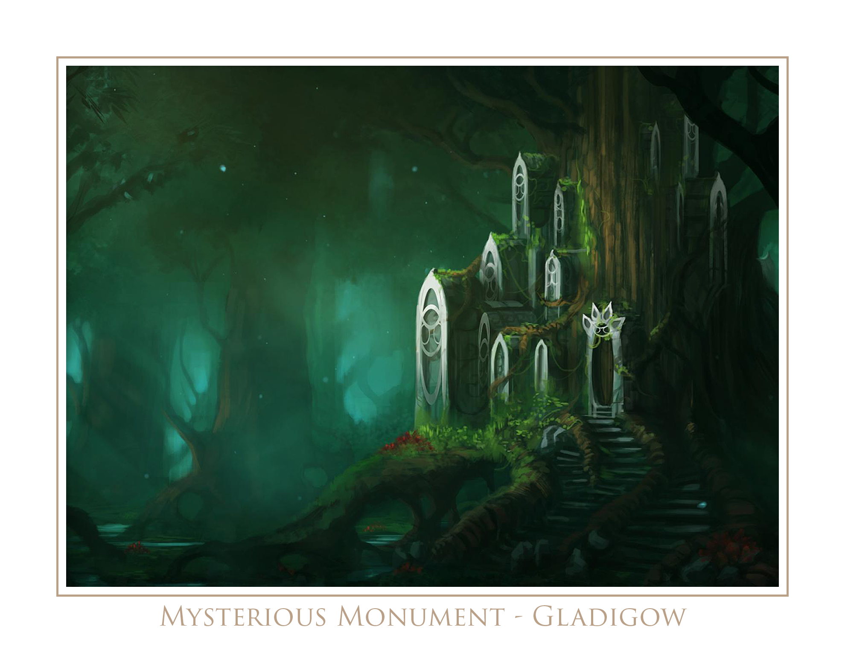

Southern - Terran

*“8 _ _ _ 1 _ _ _ 2 0” Solution: 549763*

◻ Opened ◻Conquered

**1. Craggy Room**

The room is 30’ wide and long. There are no discernible walls with a flat surface. It is particularly craggy with dull-edged boulders all around. Movement or combat in this room is to be performed at a disadvantage.

There is a lantern hanging from the ceiling with a soft blue light emitting from it, and benign faeries circling around. Roots from trees above the surface have grown into the room and seem to be sprawled intermittently along the floor and walls. On the tip of one particularly higher boulder is a perfectly smooth and flat cube that seems to be adjoined to the boulder itself.

At the opposite end of the room is an iron door with the picture of a figure in a robe holding a cube above his head with light rays protruding from it. He appears to be standing among snakes and vermin on the floor.

Next to the door is a 1’ wide hole that has a darkness spell cast upon it. The players are not able to see into it, and if they reach inside there will be a lever that if pulled will open the door.

**2. Stone Room**

The party arrives into a room that is about 20’ wide in all directions. It is dark, made of stone walls, floors and there is an unlit brazier up against the entrance wall near the door. There look to be randomly constructed shelves or alcoves that are about 5’ deep, protruding from both the left and right walls.

There is a statue of a man in the middle who looks to be wearing heavy armor. He is looking directly at a statue of a Basilisk who is standing in one of the alcoves on the wall. There is a necklace of keys around his neck.

If the party can block his gaze to the basilisk, he’ll turn into himself again. He will tell the party to get out, to abandon their pursuit of what lays in this dungeon, and then he will die of shock and trauma. His keys will work on the door.

**3. Rising Room**

The room is a dark stone cylindrical room that is 30’ tall. In the middle is a very large iron cauldron that is filled with dirty water. The cauldron has a door on it that a gnome or halfling would fit within. Along the wall every 5’ and in random positions around the room are 24” openings that are barred shut, and about 12” deep. They all have random trinkets mysteriously placed or left in them, and anyone but a human, dwarf or half-orc can reach through and grab the trinkets.

* Glass globe of murky water with a swimming worm inside.
* Stone-carved and painted figurine of a tarrasque.
* 50’ of rope that glows faintly, but cannot hold a knot.
* Key ring with several gold and silver locks, but no keys.
* Wooden puzzle piece that is solid blue.

When the party enters the room, the floor begins to raise to the ceiling slowly. The cauldron stops the floor from hitting the ceiling and crushing the party. If the party moistens the ceiling or lights a fire underneath the cauldron to create steam, the cauldron will weaken the hardened dirt ceiling and reveal an opening into the next room.

**4. Waterstone Basin**

The room appears as an area in ruins might. It is dark with scattered stone pavers along the floor and has a very strong smell of sage. There are stone columns protruding from the stone walls, and some have even broken and fallen on the floor. The stone and sandy walls are not intact, and appear to be falling apart, either from force or erosion. In the middle of the room is a decorative stone basin that is empty, but appears to have contained liquid at some point. It is spotless on the inside. It is a mysteriously magical basin that will turn dirt, stone and rocks into clean, drinkable water. The only caveat is the water is red.

The exit from the room is an iron door sealed tightly. Engraved on the door is the depiction of an expression-less, cloaked figure with his arms outstretched and water pouring from his sleeves onto the ground beneath him, and a mountain behind him. To the left and right of the door are two vases mounted on the wall, crudely, like torch braziers might be.

When the characters interpret that in their own way, do enough creative and cool shit, let them through.

**5. Gems of War**

The party enters a large room where there is a column in the middle with 3 indentations for where gems go surrounding a large gem indentation. The gems are in the room in locations that would require each party member to use their specific talent/ability to dislodge/retrieve the gem for the column. When all gems are placed, the exit reveals itself as the stone wall seems to melt an entrance into view.

|  |
| --- |
| Yellow: |
|  |
|  |
|  |
|  |

|  |
| --- |
| Teal: |
|  |
|  |
|  |
|  |

|  |
| --- |
| Pink: |
|  |
|  |
|  |
|  |

Upon completing the puzzle the exit door becomes unlocked and upon exit the party finds themselves through the front door of the dungeon, and the next portion of the map is revealed.

**Rovelle Nations**

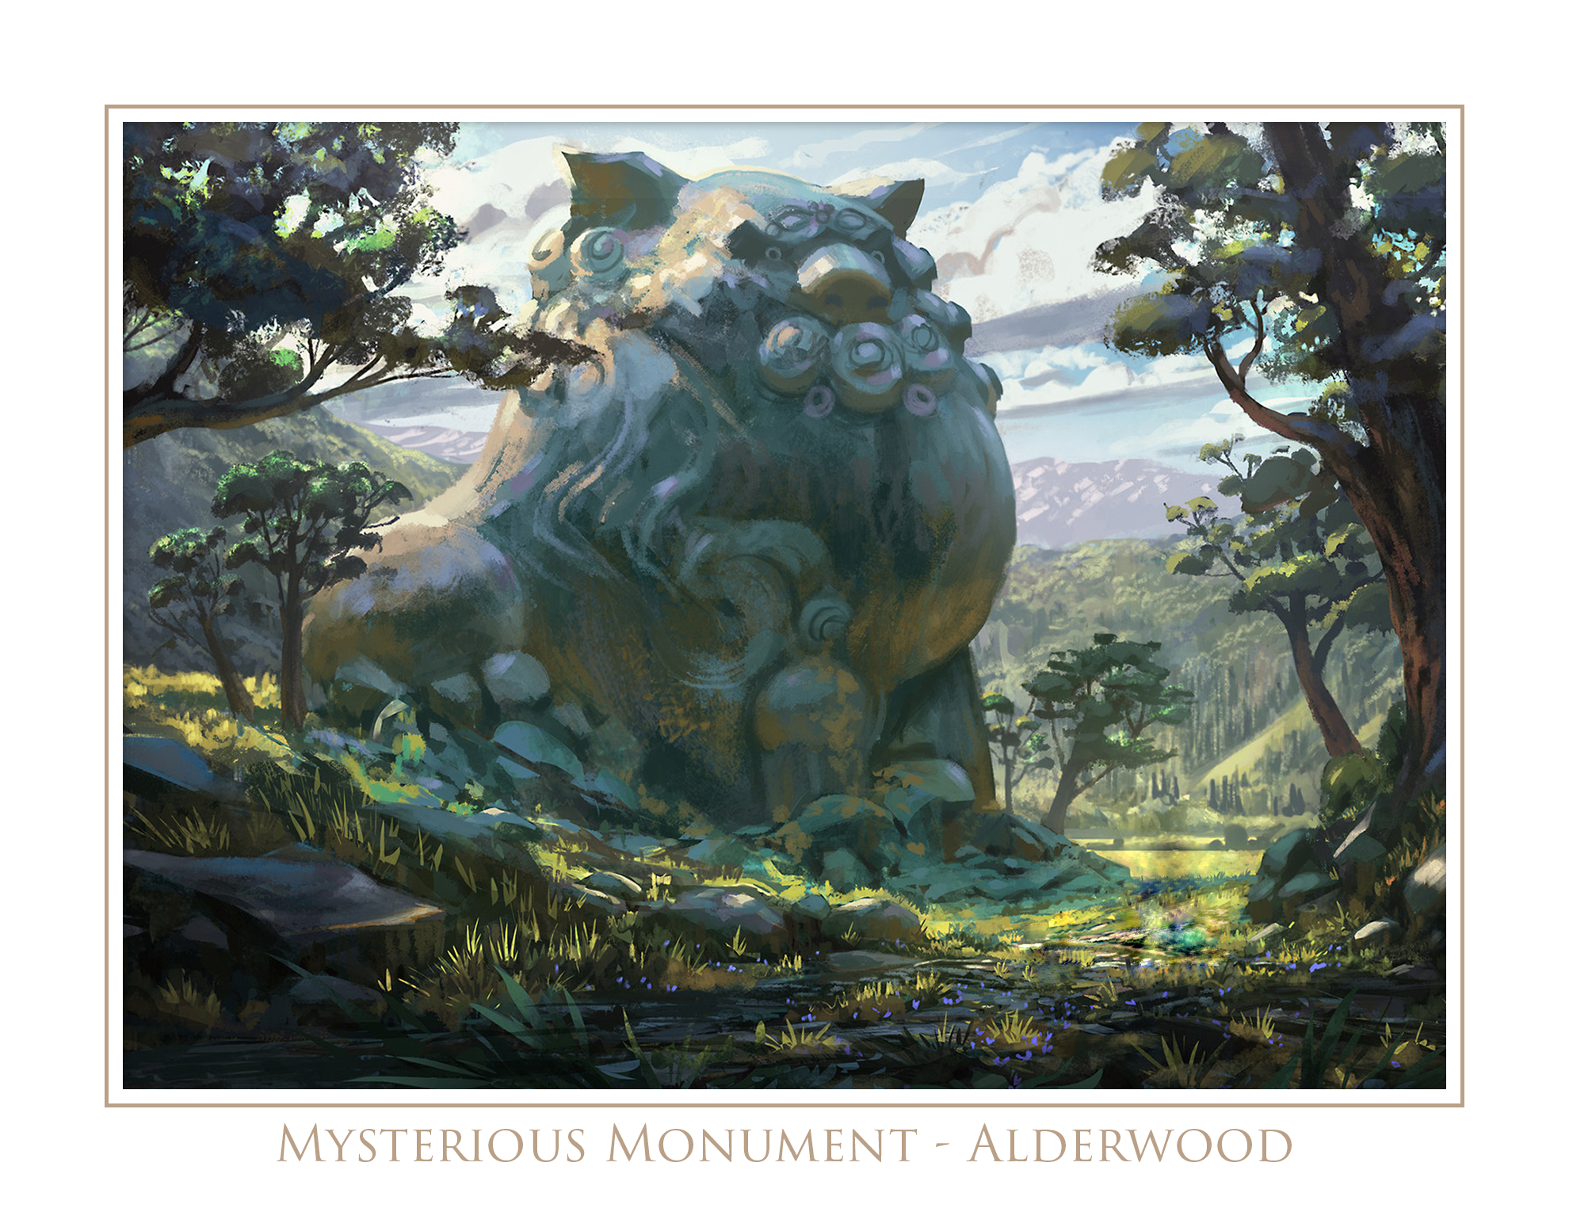

Alderwood - Gnoll

*“Another 1” Solution: One after another*

◻ Opened ◻Conquered

**1. Mouth Knocker**

The room is massive at nearly 200’ long and 100’ wide. One half of the room looks like it is in a cave with cavernous floor, ceiling and walls. There are massive eroded holes that look like a family of foxes or bats live in there. On the other side of the room it is cobbled with gray paver stones. The floor meets the wall and goes right up to a ceiling that is built with hard and thick alderwood. There are torches along the wall, but only two are lit.

Along the way the party notices remains of several direwolves, resting along the stone wall on the left side. They have been dead for weeks now.

The exiting door in the entrance room has a face of a gnoll or wolf-like creature with his mouth wide open. The players will need to put something in its mouth to use as a knocker in order to open the door. (Chain link, horseshoe, etc.)

**2. Cursed Knight’s Room**

The party enters into a large 60’ circular room with a high ceiling. The walls are constructed with stone bricks and there are torches in between various weapons that are on the wall. They are all lit. In the middle is a statue of a knight wearing plate armor, a helmet and holding his arms out with his palms facing upward. There is an engraving on a plaque at his feet that says *“Bring to me the greatest weapon, that kings covet, puts warriors to ruin, and ends all battles.”*

* Deathbringer - Warhammer, Bright yellow with leather handle, 1d6 bludgeoning, 7gp0
* Oath Shatterer - Great Sword, Blood red with Elvish inscriptions, 1d8 slashing, 30gp
* Mercy Climber - Glaive, Bright blue blade with black leather braided handle, 1d8 slashing, 11gp
* Giant Toe - Maul, Giant’s skull with mouth open and maul protruding, 1d8 bludgeoning, 5gp
* Quicksilver - Pike, Dark green Jade blade with bamboo handle, 1d6 piercing, 1gp
* Bad Samaritan - Trident, Dark golden highly reflective with Abyssal inscription, 1d4 piercing, 1gp
* Midnight Sun - Quarterstaff, Braided dark and light wood with teal crystal inlays, 1d4 bludgeoning, 2cp
* Peacemaker - Longsword, Rusted with olive branch wrapped around it, 1d6, 9gp
* Kingslayer - Morningstar, Black handle with milk white head sculpted with face, 1d6 piercing, 9gp
* Widowmaker - Longbow, Cherry wood with yellow crystal inlays, 1d6 piercing, 20gp

Putting any weapon in the hand of the statue causes it to become an animated weapon that attacks. Among the weapons is a sword called “Peacemaker” with an olive branch wrapped around the rusted blade. Placing the olive branch in the hand of the statue solves the puzzle.

**3. Pendulum Platforms**

The room is massive at 100’ by 50’ with a short ledge upon entrance that seems to end at a ledge that descends into a misty pit that spans the entire room leading to the opposite end where another ledge holds the exit door against the wall. Between both doors, hanging above the misty pit are several hanging platforms held up by my massive iron linked chains. Players are only allowed to jump half their STR since there is no space

Perception checks while standing into the pit reveal the mist. The walls reveal nothing too. If the players kneel and make a dedicated perception check below the ledge they will discover a recessed opening with a lever that if pulled will cause a 10’ bridge to rise from the floor. The mist is so thick that the players are unable to see past the mist at the floor.

**4. YMCA**

The party enters a room with 4 stone tablets recessed into intricately masoned stone pedestals that seem to rise right out of the ground. Each tablet has a word on the bottom, and a simple picture engraved on them.

On the first tablet is graven YOTH in the Dwarven system, which stands for strength and resembles a forked truss in a mine shaft.

On the next is graven MIRIL in Elven, which stands for grace and resembles a willowy fountain with two rounded arcs of water.

Next over is the Draconic CROF which means treachery, and is the shape a knife takes as it swings down into an ally's back.

Last is ALFARD, first in the common alphabet, which symbolizes beginnings. It looks like a long road or ladder laid out before a traveler.

When the party does the action of YMCA in front of each tablet, in the correct order, the tablet begins to glow. When all four have become activated, a collection of stones in the wall fold away from the wall and reveal an exit hallway with lit braziers on the wall, leading 30’ to a massive iron door. There is an engraving on the door of a depiction of several heroes brandishing swords, a bow and a quarterstaff that are circled around what looks like a three headed wolf, standing on its hind legs and holding a flaming sword over his head. The door is not locked or trapped.

**5. Gems of War**

The party enters a large room where there is a column in the middle with 3 indentations for where gems go surrounding a large gem indentation. The gems are in the room in locations that would require each party member to use their specific talent/ability to dislodge/retrieve the gem for the column. When all gems are placed, the exit reveals itself as the stone wall seems to melt an entrance into view.

|  |
| --- |
| Green: |
|  |
|  |
|  |
|  |

|  |
| --- |
| Red: |
|  |
|  |
|  |
|  |

|  |
| --- |
| Blue: |
|  |
|  |
|  |
|  |

Upon completing the puzzle the exit door becomes unlocked and upon exit the party finds themselves through the front door of the dungeon, and the next portion of the map is revealed.

(Optional) Upon exiting the dungeon the party will be ambushed by a group of elite gnolls. If they helped aid the cyclops’ sheep by staying guard after the seemingly final battle with the bugbear and goblins outside the cave, the cyclops will show up and fight the elite gnolls with the party.

✶

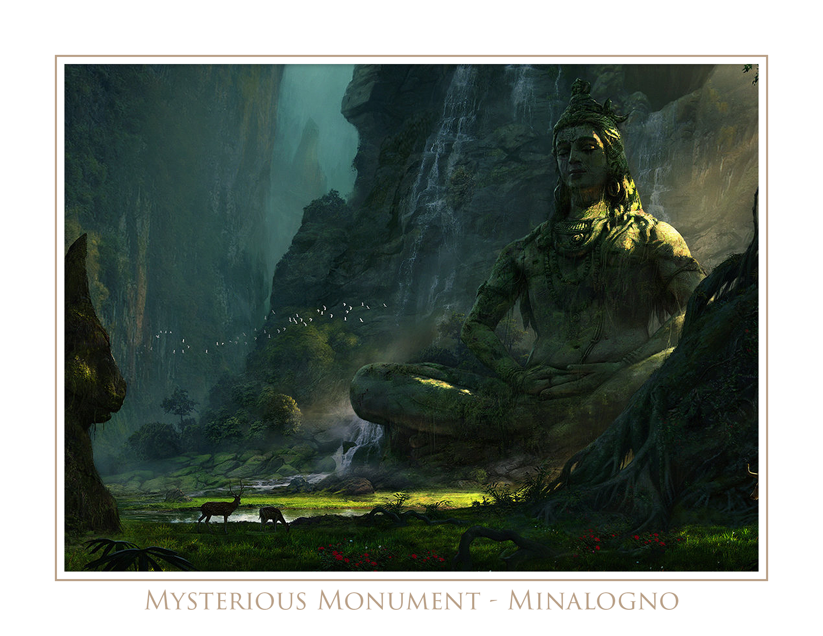

Minalogno - Aquan

*“That which may never break upon the land, but crumble on the water” Solution: Waves*

◻ Opened ◻Conquered

**1. Slip and Slide**

The door which the party enters has a large I engraved on it. The threshold is dry, but there is a heavy musty smell in the air. There appears to be light reflecting water rippling on the ceiling with no discernible source. The room is 100’ long and 15’ wide, and ascends to the opposite end where a stone door is at the top. Along the length of the hallway are a number of lit braziers. Sitting just above the door, and seeming to hang in midair is a glass sphere of water with many gold and silver coins resting on the bottom.

The glass sphere is actually a gelatinous cube that has taken the form of a container it was within. It will fall if struck, and tumble over the party if they do not succeed on several DEX checks.

The exiting door has a large II engraved on it. It opens with no unlocking necessary. There is 1,300gp, 740sp, a mysterious ring (Ring of “Invincibility” that makes the finger wearing it disappear), +1 morningstar, and a +2 dagger.

**2. Central Room (II)**

10’ wide ledge going around the perimeter of the room with a 50’ deep pit in the middle revealing the top of a rushing, rapid river. The diameter of the pit is about There are 4 corridors connecting into this room. The party has just entered through the southern door. Each corridor is sealed with a tomb door that cannot be broken or picked with Thieves’ tools.

If the party looks in the pit, WIS DC5 will reveal that there are actually four square shaped openings that recess into the walls. These openings are about 15’ down from the ledge and go about 10” deep. In these recessions are iron levers. It appears that the doors are opened by these levers since there are four and one is opened, and the **first lever** will be pulled in a different position than the others.

When a **second lever** is pulled, a 12” opening in the ceiling against the walls begins to flood the room making standing on the ledge very difficult. Every so often ask the party to make a CON DC7 or risk being too exhausted from the strain of standing against the crashing water and fall into the pit taking 1d20 bludgeoning damage from the rushing water and immediately beginning a countdown before you drown. If a **third lever** is pulled, the entire room is cast with the darkness and silence spell. If the final and **fourth lever** is pulled the room returns to normal, and the northern door is opened.

**3. Black Pool (northern door/III)**

A dark 50’ corridor that slopes downward revealing a large room at the end that is brightly lit with a green hue. There will be slime that is sticking to the wall along the way down.

The room at the end has a large pool of water in the middle in a square shape. The water is placid and pitch black. There appears to be an adventurer's pack floating on the surface. Above the pool is a motion-less apparition of a skull that seems to be within a sphere of some sort, be it glass or some magical surface. The skull is actually producing all the light in the room.

If the party pulls the pack out they will see that it is bloodied, torn and containing rope, a bedroll, a harmonica, 11gp, 53sp and a lucky coin.

If the party sticks their hand in the water they will be attacked by quippers in the water. They cannot illuminate into the pool as the blackness is absolute as long as the skull is illuminated. In order to illuminate the pool the skull will need to be killed. When attacked it will reveal itself to be a demilich.

When the demilich is killed, the party can illuminate the pool with any source of light: torches, faeries fire, etc. The pool is about 8’ deep, and there is a swarm of quippers swimming around. The water is now crystal clear with an assortment of bones at the bottom.. The pool seems to go underneath the floor beyond the visible pool opening on the surface. 10’ deep beneath the western floor is a lever that opens the northeastern door from the central room. The lever is affixed to the floor of the pool, and it opens the door marked with a IV from the central room.

**4. The Water Maiden (northeastern door/IV)**

In this small stone room there are 11 columns along the wall going from ceiling to floor. Each column has a torch brazier mounted to it. Two torches are dimly lit. There is a statue of a naked maiden in the position of holding a bowl in one hand that is broken with the various shattered pieces on the floor. In the other hand there is a pitcher that is still intact that she appears to be pouring into the bowl.

The ceiling is a flat stone surface with a dilapidated fresco scene painted on it. It is difficult to make out the painting. In the middle, directly over the statue is a circular recession, about 3’ wide. There is no erosion present, nor the painting on the rest of the ceiling.

WIS DC15 reveals that behind one of the columns is a spell scroll lying flat under a thick layer of dust that, with the dungeon’s humidity has become almost like a soft and thin layer of mud. It is a Water Breathing spell scroll.

When the remaining two braziers are extinguished, and if the bowl can be repaired, a cyan colored spectral orb will illuminate above the statute and light the entire room. At this point water will begin to pour endlessly into the small bowl, and not overfill. A series of clicks and other mechanical noises can be heard from beneath the ground and in the walls. The door with the V engraved on it will now be open.

**5. The Dark Abyss (southeastern door/V)**

When the party enters the door with the V engraved on it, they will come into a room that is a long corridor with several of the same cyan colored spectral orbs on the ceiling lighting the way. There is a door at the end that reads in the Aquan language: *“Walk these halls and return to me, a letter is key.”*

The character(s) must say the letter *“K”*

Within the room it is filled completely with water. The water does not spill out of the room when the door is open however, it remains placid and suspended in the air from ceiling to the floor. The room is under a spell of darkness and silence.

There are four walls in the room creating a pathway in the shape of an H. At the end of each smaller corridor is a lever on the wall, except for one that has a large bronzed bust of a shark protruding from the wall. *This is a red herring, it does and means nothing.*

The three levers need to all be pulled at the same time, and when this happens a sealed opening in the middle of the room, on the ceiling, opens. All the water in the room gets sucked upward into what appears to be a celestial vacuum of some sort in infinite darkness, and then it closes. The spells of darkness and silence are also lifted, and the portion of the party’s map will be revealed at this time.

**Republic of Voli**

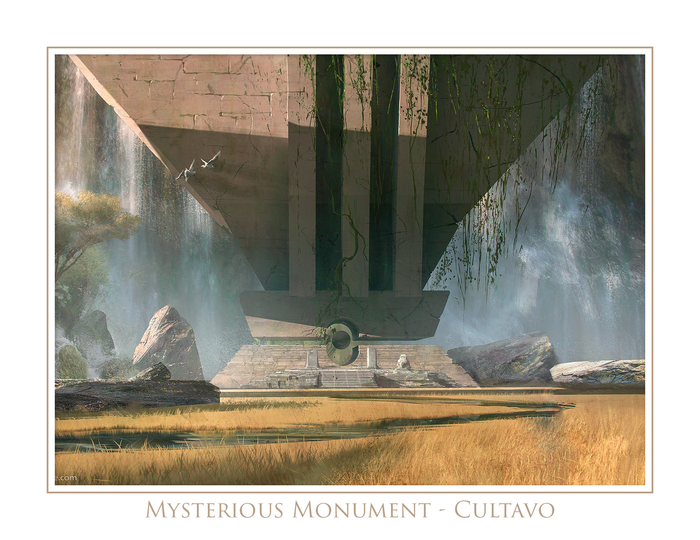

Cultavo - Common

*“B H I O D E X C _” Solution: K*

◻ Opened ◻Conquered

**1. Double Decker**

A stone room foyer entrance with a stair well leading upward and a stair well leading downward, with lit braziers on both sides of the entrance door. The stairs ascend/descend 10’. Both rooms are 45 square feet.

Upper - This room has a large steel grate center that measures 15 square feet. Through the floor you can see the bottom floor. The left and right side walls have cavernous openings that appear pitch black and mysteriously deep. They are raised 10’ above the ground. There is one lit brazier on the far wall emitting light to just more than half the room, including the steel grated floor.

Lower - The room has an iron door on the far opposite wall with an engraving that appears to be two steady streams of skulls and bats converging at one point in the middle where a crossed sword and axe is. There are two braziers on each side of this door and neither are lit. Until the they are lit, the party cannot see very well in this entire room.

When the party steps on the steel grate on the upper floor it’ll activate the portcullises inside of each cavernous opening and release one creature who will attack the upper floor party members. New creatures will enter the room as they are defeated.

Simultaneously, there will be a pedestal with a puzzle that will raise from the ground to be solved. The puzzle can only be solved while it is revealed, having two party members on the steel grate above putting enough weight to activate the mechanism that pushes the pedestal upward. As soon as there is not enough weight on the grate the pedestal/puzzle fall immediately into the floor.

The puzzle can be a physical puzzle that the player is able to solve. Be sure to provide them a mini-screen so the other players can’t see them solve the puzzle.

As soon as the puzzle is solved any monsters on the upper floor will disintegrate into thin air, and the sealed door on the lower floor will open.

**2. Hero Trio**

The room is a standard sized room with a beautiful, intricate braided pattern engraved into left and right walls. On the wall, opposite to the entrance is a blank iron door that is behind a portcullis door with iron bars. In front of those bars is what appears to be a steel mesh door that is activated on a pulley system. The floors are stone and the room is barren except for three statues in the middle, sitting on pedestals. They are all life-sized, and very well crafted by the artisan.

1. Left is a gnome holding a set of unbalanced scales with two large plates.
2. Middle is an elven archer with her bow drawn towards the entrance of the room.
3. Right is a dwarf holding a very beaten up, and even seemingly eroded, battle axe.

When enough weight is placed on the scales of the gnome, the first steel mesh door will rise, and the elf will fire its arrow across the room into small slit in the stone, a clicking sound will be heard from the dwarf statue.

The dwarf statue can now be rotated, and if faced towards the exit wall, a mechanism will be triggered to cause the portcullis bars to fall into the ground, and cause a portion of the floor to fall several inches downward, and slide inward, revealing a relatively large and short gaping hole at the foot of the exit door.

This hole is a key hole that can be picked (DEX DC20 Thieves’ tools), but is meant to be inserted with the dwarf’s axe, which is not beaten up as originally described and likely assumed; It’s a large key.

**4. Portal Room**

The room is a large square room with four doors on each face, with the party entering from one of them. If they go through any of the doors they’ll find that the doors just go to the opposite side of the room. If they do a WIS DC15 check they’ll find a lip on the floor that belongs to a door that if they swing open will also swing open a ceiling door. The ceiling/floor door does not act in a dual manner though, like the wall doors. What goes down the floor comes through ceiling, but what goes into the ceiling door goes into the exit alcove that leads down a 30’ hallway to the next room.

**5. Sorted Sordid & Sworded**

The party enters upon what looks like a throne room, adorned in silk banners on stone walls, with large colorful glass mosaic windows depicting scenes of several fair skinned maidens picking flowers, reading books and holding hands with other maidens. There is common throne-room furniture like pedestals, tables with common wares, decorative chairs and candle stands, lit. There are also crossed swords on both sides of the room, resting upon shields with some unknown sigil on the front.

There is a bright red rug leading from the entrance door to what appears to be an altar with 3 pedestal recessions on it. Behind the altar are 9 stone statuettes.

* Quill with ink bottle
* Man with abacus ✔
* Warrior with spear
* Warrior with bow
* Prostitute ✔
* Bear
* Apple
* Smith with hammer and forge ✔
* Rooster

When the party interacts or approaches the altar a voice in the room says to them, *“You who wish to be rewarded--choose the three that keep things sorted/sordid/sworded.”*

If the party chooses the wrong 3 statuettes, a monster attacks the party. For each incorrect combination of statuettes placed on the altar, a negative effect is introduced to the room.

* Grease
* Silence
* Darkness
* Three illusory wraiths appear
* Body numbness (one handed)

When the 3 correct statuettes are placed on the pedestal recessions, the statuettes seem to lock in place on the altar’s top and then descend into the altar. Moments later the recessions open up and instead of the statuettes ascending back through the holes, three potions: Potion of Flying, Potion of Gaseous Form, and Potion of Mind Reading. The next portion of the party’s map is revealed as well at this point.

✶

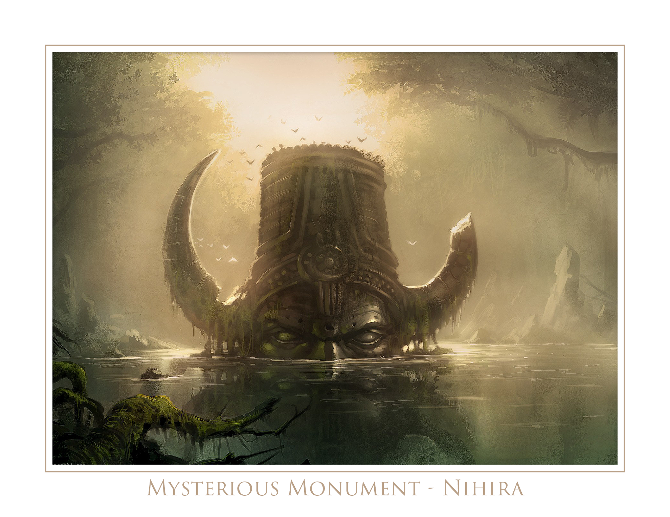

Nihira - Primordial

*“You can swallow me, and I can swallow you.” Solution: Water*

◻ Opened ◻Conquered

**1. Primordial Visions**

The entrance room is medium sized of around 30 square feet with a large stone tabernacle in the middle resting on a podium just lifted off the ground. The walls are filled with a blue-green sticky fluid that seems to have hardened, but is tacky upon touch. It smells like death.

The floors are oddly paved with triangular stones, and the door leading to the next area is iron with an engraved scene depicting a ten-sided start in the middle with an array of symbols and imagery surrounding. There are animals, flowers, faces, shapes, weapons and runes. There is a script along the top that reads in Primordial, *“Life leads us down dark roads, but sometimes that is necessary to see the light.”*

On the tabernacle is a book that seems to be made of flesh. It is written in the Primordial language, and requires a short rest to read. It reveals that the tabernacle can be used to see into the past. DC15 INT check, and the ability to read Primordial is required by the player to properly perform the action. The caveat is that they can only perform the action once, and then the book disappears out of the character’s hands. It resets after the new moon.

When the book disappears a ruby seems to appear out of nowhere on top of the tabernacle. It is the size of a fist, and appears priceless. DC10 History check reveals it is the Eye of Hadron.

**2. Dark Staircase**

The room enters to a stone-masoned staircase that seems to descend into darkness. There are unlit braziers mounted to both sides of the wall. The endpoint of the stairwell cannot be seen with any form of light.

As long as the party continues to walk they will eventually require CON checks to maintain focus and ward off exhaustion from walking down the stairs. They may even take superficial levels of bludgeoning damage as a result.

The characters must put out all sources of light, and any characters with darkvision must close their eyes. The bottom of the stairwell will reveal itself to the players if they continue to walk in complete darkness.

**3. Enter to Exit**

This room contains a metal and wooden door. Party enters through wooden door and door closes behind. They kill monster inside and when they exit through metal door they actually come back through wooden door again, with re-animated monster. To exit the loop they must exit back through the wooden door.

**4. Fig Room**

The room is a narrow and long room about 15’ wide with a mural painted as a fresco on the walls depicting a fig tree with mysterious faces of noble individuals painted on branches. It appears like a family tree.

In the middle of the room and turned on its back with the lid open is a simple wooden chest. There is nothing inside. As the party approaches the exit, one of the faces on the mural will say to the party *“In the middle of fig is the key.”*

The solution is to put the Eye of Hadron in the chest, close it, and the door will open. In the middle of fig is the letter ‘I’, or ‘eye’.

**5. Gems of War**

Upon entering the room you immediately notice that all of your belongings are in neat piles in front of the door. In a room there is a column in the middle with 3 indentations for where gems go surrounding a large gem indentation. The gems are in the room in locations that would require each party member to use their specific talent/ability to dislodge/retrieve the gem for the column. When all gems are placed, the exit reveals itself as the stone wall seems to melt an entrance into view.

|  |
| --- |
| Orange: |
|  |
|  |
|  |
|  |

|  |
| --- |
| Gray: |
|  |
|  |
|  |
|  |

|  |
| --- |
| White: |
|  |
|  |
|  |
|  |

Upon completing the puzzle the exit door becomes unlocked and upon exit the party finds themselves through the front door of the dungeon, and the next portion of the map is revealed.

**Jumal Empire**

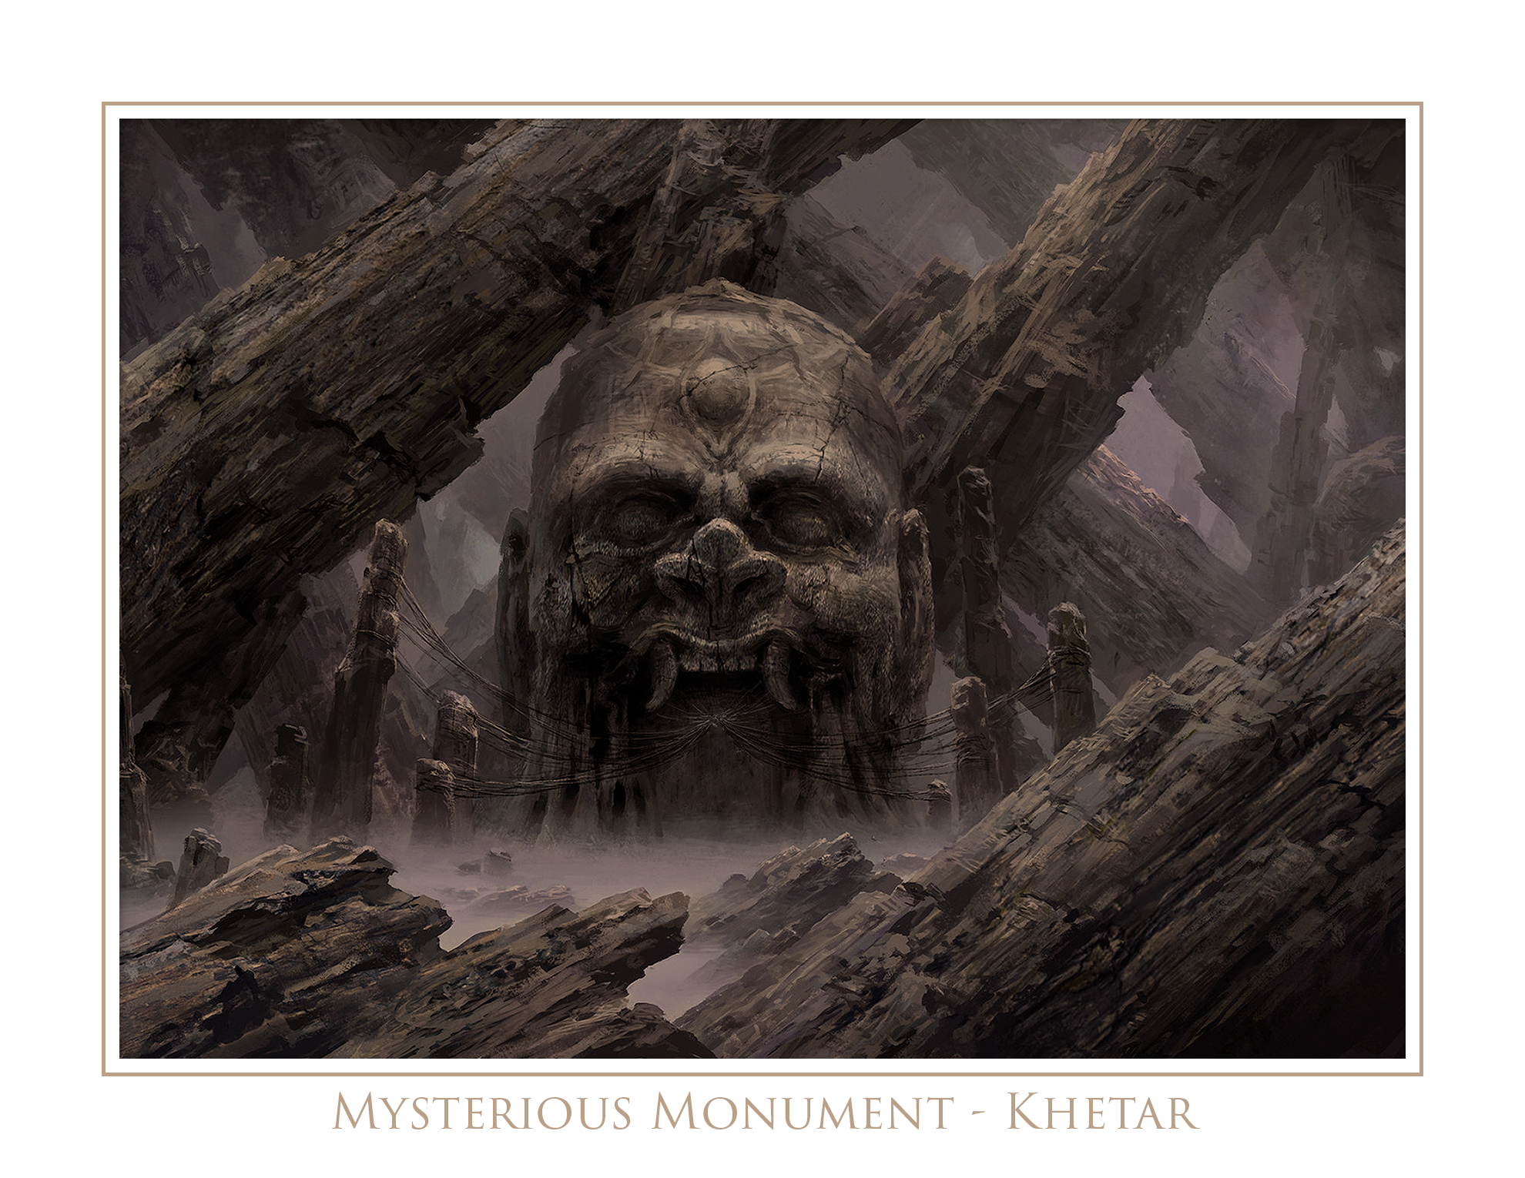

Khetar - Draconic

*“Lovely and round, I shine with pale light, grown in the darkness, a lady’s delight.” Solution: Pearl*

◻ Opened ◻Conquered

**1. Two Serpents**

The entrance to the first room is guarded by a yellow aura that rests on the threshold. It appears, sounds and even smells benign. As you enter the room a sudden rush of heat pours through your body and then it’s gone. You feel lighter.

You enter into a stone brick room that is about 10’ wide and 60’ long. The ceiling is 20’ high. About 40’ down the room is a very large wooden cylinder, like a barrel that is 8’ high, and is resting on its side. There is about 1” of clearance on each side of the barrel. On the other side of the barrel is an incline or a ramp that goes up about 30 degrees. Halfway up the incline is a door on the left wall that is closed.

The big wooden cylinder is made of pure alderwood and is actually hollow. There is a rather large hole on the side that is currently facing the ceiling. On the side of the cylinder facing the party now is a note that is gently tacked to it that reads in Draconic, *“Serpents inside. Do not disturb.”*

WIS DC10 reveals that the serpents inside are not moving, and are calm. INT DC10 reveals that if the cylinder is moved they will become active and vicious, striking at anything within its reach.

WIS DC15 reveals that there is trap door on the wall that can be punched in with a strength of STR DC10, revealing a small alcove that holds a Ring of Spell Storing. On the ring are two spells: Animal Trance and Animal Hold.

Hint to the players can be revealed with a INT DC5, that the cylinder rolls both ways.

* Climbing on cylinder: DEX DC10
* Walking cylinder: DEX DC15
  + Failed (+4) 1-2L, 3-4R, 5-6T
  + Faile Hole^ DEX DC15 save
* Pushing cylinder: STR DC20

**2. Gems of War**

Upon entering the room you immediately notice that all of your belongings are in neat piles in front of the door. In a room there is a column in the middle with 3 indentations for where gems go surrounding a large gem indentation. The gems are in the room in locations that would require each party member to use their specific talent/ability to dislodge/retrieve the gem for the column. When all gems are placed, the exit reveals itself as the stone wall seems to melt an entrance into view.

|  |
| --- |
| Violet: |
|  |
|  |
|  |
|  |

|  |
| --- |
| Yellow: |
|  |
|  |
|  |
|  |

|  |
| --- |
| Red: |
|  |
|  |
|  |
|  |

**3. Water Mouth**

The party enters a round room that is brightly lit with fresh torches mounted on the wall and they’re met with the loud pouring of water cascading from the ceiling out of a stone head of a dragon that is about 4’ large and about 25’ high. It is mounted to a round recessed track and appears like it is meant to turn in a circular fashion along the ceiling.

The walls and floor are not made from stone, but rather formed naturally from the earth in the ground, the stone. There are however, natural openings in the floor, 3 of them to be exact, and they are wide enough to capture the entire dragon mouth’s stream of water falling out of it.

If the party searches into the holes they will find a pool of water that goes nowhere. The solution is to block the three openings in the floor and to flood the room so that the water rises all the way up to the ceiling and the party can swim through the dragon’s into the next room which contains an eternal pool of water from which the dragon’s head pours.

**4. Orpar Cave**

Once the party comes through the pool they’re met with a beautiful cavernous setting of stalactites, colorful crystals and a small shore of sand and stone. The room is only around 50’ large with a ceiling that sits about 100’ from the floor.

WIS DC20 will reveal that there is a dark, recessed alcove about 15’ high in the western wall. If the party manages to climb in there they’ll find a Ring of Djinni Summoning. DEX DC15 will prove a successful climb.

On the far wall from the pool of water is a large flat surface with a beautifully engraved circular mosaic-like design that is inlaid with copper and shalestone. There is an outer ring of 19 letters:

ZQKARLCTMDVNFWOGXPJ

On the inside it reads *“Come, human, die by sword or spear.”*

The following letters are missing from the outer ring: BEHISUY. When those letters are removed from the phrase, it reads *“Command word ORPAR”.* When the command word is spoken the wall turs into a staircase and leads upwards 100’ with crystal white lit torches along the walls guiding the way. At the top is an ivory door with a scene engraved depicting a dragon’s head with flowers in its mouth. There appear to be honey bees flying around its head.

**5. Trapsweeper**

The party enters into a room with 100 pressure plates on the ground in a 10x10 configuration. Each plate is 5’ wide. As soon as they enter the room the door seals them in. A white dragon of the appropriate size will descend from an enormous alcove built into the wall, up against the ceiling. The party must eliminate all the trap-less pressure plates in order to find hidden portion of the world map which will fall from the ceiling when released.

|  |  |  |  |  |  |  |  |  |  |
| --- | --- | --- | --- | --- | --- | --- | --- | --- | --- |
|  |  |  |  |  |  |  |  |  | T |
|  |  |  | T |  |  |  | T |  |  |
| T |  |  | T | T | T |  |  |  | T |
|  | T | T | T | T |  | T |  |  |  |
| T |  |  | T |  |  | T | T | T |  |
| T | T |  | T | T | T | T |  | T | T |
| T |  | T |  |  |  |  | T | T | T |
|  | T | T |  |  |  |  | T |  | T |
| T | T |  |  |  |  | T |  | T |  |
|  |  |  |  | T |  |  |  |  |  |

Trapping pressure plates will require DEX DC15 to disarm without Thieves’ tools, DEX DC10 with, and will push out a sprig of razor sharp stone spikes from the ground. These spikes do 1d8 piercing damage with a DEX DC10 saving throw to the trap area, and each adjacent area as well.

When all of the areas are cleared and all that are left are traps, the dragon will return to its alcove and ignore the party. The next portion of the map will then be revealed, and the dungeon will be completed.

✶

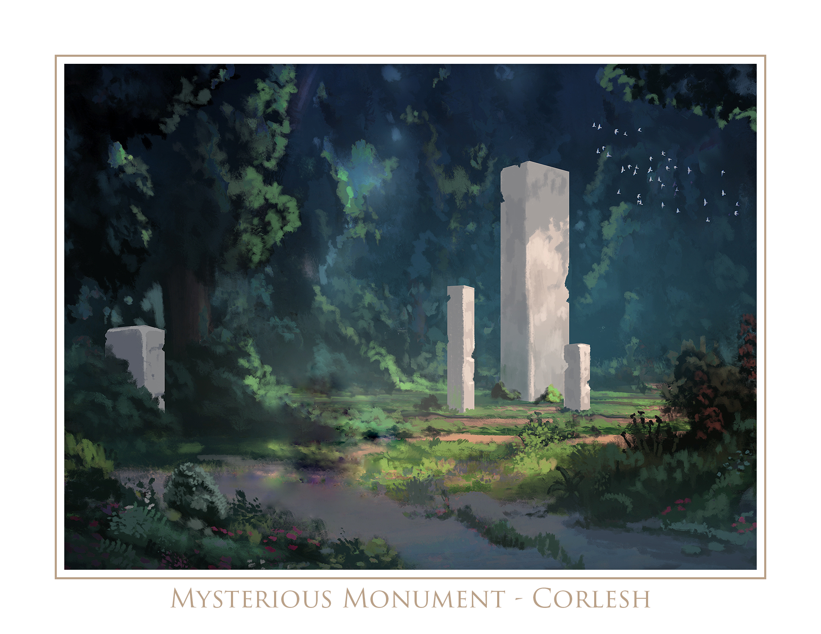

Crolesh - Elvish

*“Easily broken, but unable to be touched.” Solution: Promise*

◻ Opened ◻Conquered

**1. String Room**

The party is met with a wooden staircase that makes a steep descent, roughly 13’ The party enters a room that appears as a wooden shanty with wood ceiling, walls and floor. The wood is very clean and finely milled with perfect angles all over. It is a warm chestnut brown color and there are almost no splinters. In all four corners are torch stands with softly lit candles illuminating the entire room. On the opposite wall is an iron door with an elaborate depiction of a very fat and naked man who appears to be nimbly walking on water while above him stares two large eyes. He looks happy. DC20 DEX to unlock with Thieves’ tools.

In the middle of the room is a 5’ wide wooden platform that sits just above the floor with a large dark bronzed statue of a naked fat man with a long flowing beard, sitting with his legs crossed. He has a large smile with great big teeth, and is holding his hands up with his palms facing each other and a gap between of shoulder width.

Between his hands is a piece of blue silk string that is hanging from one hand to the other.

When the string is broken, the iron door unlocks audibly with a series of clicks.

**2. Parchment Room**

The party is met with a wooden staircase that makes a steep descent, roughly 13’ The party enters a room that appears as a wooden shanty with wood ceiling, walls and floor. The wood is very clean and finely milled with perfect angles all over. It is a warm chestnut brown color and there is almost no splinters. In all four corners are torch stands with softly lit candles illuminating the entire room. On the opposite wall is an iron door with an elaborate depiction of a very fat and naked man who appears to be nimbly walking on water while above him stares two large eyes. He looks happy. DC20 DEX to unlock with Thieves’ tools.

In the middle of the room is a 5’ wide wooden platform that sits just above the floor with a large dark bronzed statue of a naked fat man with a long flowing beard, sitting with his legs crossed. He has a large smile with great big teeth, and is holding his hands up with his palms facing each other and a gap between of shoulder width.

Between his hands is a thin piece of golden parchment paper that is hanging from one hand to the other.

When the parchment paper is broken, the iron door unlocks audibly with a series of clicks.

**3. Stone Room**

The party is met with a wooden staircase that makes a steep descent, roughly 13’ The party enters a room that appears as a wooden shanty with wood ceiling, walls and floor. The wood is very clean and finely milled with perfect angles all over. It is a warm chestnut brown color and there are almost no splinters. In all four corners are torch stands with softly lit candles illuminating the entire room. On the opposite wall is an iron door with an elaborate depiction of a very fat and naked man who appears to be nimbly walking on water while above him stares two large eyes. He looks happy. DC20 DEX to unlock with Thieves’ tools.

In the middle of the room is a 5’ wide wooden platform that sits just above the floor with a large dark bronzed statue of a naked fat man with a long flowing beard, sitting with his legs crossed. He has a large smile with great big teeth, and is holding his hands up with his palms facing each other and a gap between of shoulder width.

Between his hands is a gray, thin stone stick that is extending from one hand to the other.

When the stone stick is broken, the iron door unlocks audibly with a series of clicks.

**4. Brass Room**

The party is met with a wooden staircase that makes a steep descent, roughly 13’ The party enters a room that appears as a wooden shanty with wood ceiling, walls and floor. The wood is very clean and finely milled with perfect angles all over. It is a warm chestnut brown color and there are almost no splinters. In all four corners are torch stands with softly lit candles illuminating the entire room. On the opposite wall is an iron door with an elaborate depiction of a very fat and naked man who appears to be nimbly walking on water while above him stares two large eyes. He looks happy. DC20 DEX to unlock with Thieves’ tools.

In the middle of the room is a 5’ wide wooden platform that sits just above the floor with a large dark bronzed statue of a naked fat man with a long flowing beard, sitting with his legs crossed. He has a large smile with great big teeth, and is holding his hands up with his palms facing each other and a gap between of shoulder width.

Between his hands is a brass cylinder about 3” in diameter that is extending from one hand to the other. There is an intricate braided molding on the cylinder and it is not obvious if it is solid or hollow by looking at it. Tapping it reveals that it is in fact hollow.

When the brass cylinder is broken, the iron door unlocks audibly with a series of clicks.

**5. Staff of Power Room**

The party is met with a wooden staircase that makes a steep descent, roughly 13’ The party enters a room that appears as a wooden shanty with wood ceiling, walls and floor. The wood is very clean and finely milled with perfect angles all over. It is a warm chestnut brown color and there are almost no splinters. In all four corners are torch stands with softly lit candles illuminating the entire room. On the opposite wall is an iron door with an elaborate depiction of a very fat and naked man who appears to be nimbly walking on water while above him stares two large eyes. He looks happy. DC20 DEX to unlock with Thieves’ tools.

In the middle of the room is a 5’ wide wooden platform that sits just above the floor with a large dark bronzed statue of a naked fat man with a long flowing beard, sitting with his legs crossed. He has a large smile with great big teeth, and is holding his hands up with his palms facing each other and a gap between of shoulder width.

Between his hands is a dark red, wooden cylinder about 2” in diameter that is extending from one hand to the other. There is no design or engraving on it, and it is not obvious if it is solid or hollow by looking at it. Tapping it reveals that it is in fact hollow, but with a WIS DC15 check the player will hear that it is hollow but with something inside of it that is loose. STR DC20 will break the wooden outer cover without breaking the contents which is a miniature Staff of Power with 2 charges remaining of Fireball.

When the Staff of Power inside of the wooden cylinder is broken, two 5th level Fireballs erupt in the middle of the room, the room explodes in a shower of fine chestnut lumber and the party falls through the floor. The explosion will reveal that the entire series of rooms was inside of a seemingly infinite abyss of pure darkness. The party will fall 20’ to the ground and take an additional 2d6 of bludgeoning damage.

Should the party break the wooden cylinder and safely remove the Staff of Power the final door in the room will open with a series of audible clicks, and the party will need to voluntarily enter in the darkness below to advance.

The party will be able to see the 4 rooms hanging above them, appearing to float in the blackness, with the fifth room clearly blown off of the rest.

If the party inspects the floor they will feel that is has little holes in it too big to stick their fingers into. If the party decides to walk in any direction they will do so and forever, never meeting a wall. There are no monsters, but there will be the occasional sound of running feet out beyond their vision.

If the party inspects the bronze statue remnants will show that it was hollow, and inside is a box. If the party entered the abyss, and didn’t explode into it they will need to get back up there to inspect any of the statues to break it open to retrieve the box.

When the lid of the box is opened, the sky above them reveals the party looking down into the box at themselves. The party will need to pull themselves out of the box and into the room on the ground so they can jump into the small holes on the floor.

By jumping or descending into the holes they all enter through the same hole in a room that is identical to the wooden rooms from the rest of the dungeon.

The party enters through a hole in the ceiling of a room that appears as a wooden shanty with a wood ceiling, walls and floor. The wood is very clean and finely milled with perfect angles all over. It is a warm chestnut brown color and there are almost no splinters. In all four corners are torch stands with softly lit candles illuminating the entire room. On one wall is an iron door with an elaborate depiction of a very fat and naked man who appears to slapping hands with another very fat and naked man. They seem to be skipping and appear happy. DC20 DEX to unlock with Thieves’ tools.

In the middle of the room is a 5’ wide wooden platform that sits just above the floor with a large dark bronzed statue of a naked fat man with a long flowing beard, sitting with his legs crossed. He has a large smile with great big teeth, and is holding his hand up his palm facing outward, while his other hand holds up two fingers. The open palmed hand is garnishing 3 similar looking rings (Rings of Protection.)

The solution is that only two party members need to slap the statue’s hand at the same time, and at that point the door will unlock with an audible indicator of clicks and knocks. The door will exit to the front entrance of the dungeon and at that point the next portion of their map will be revealed.

✶

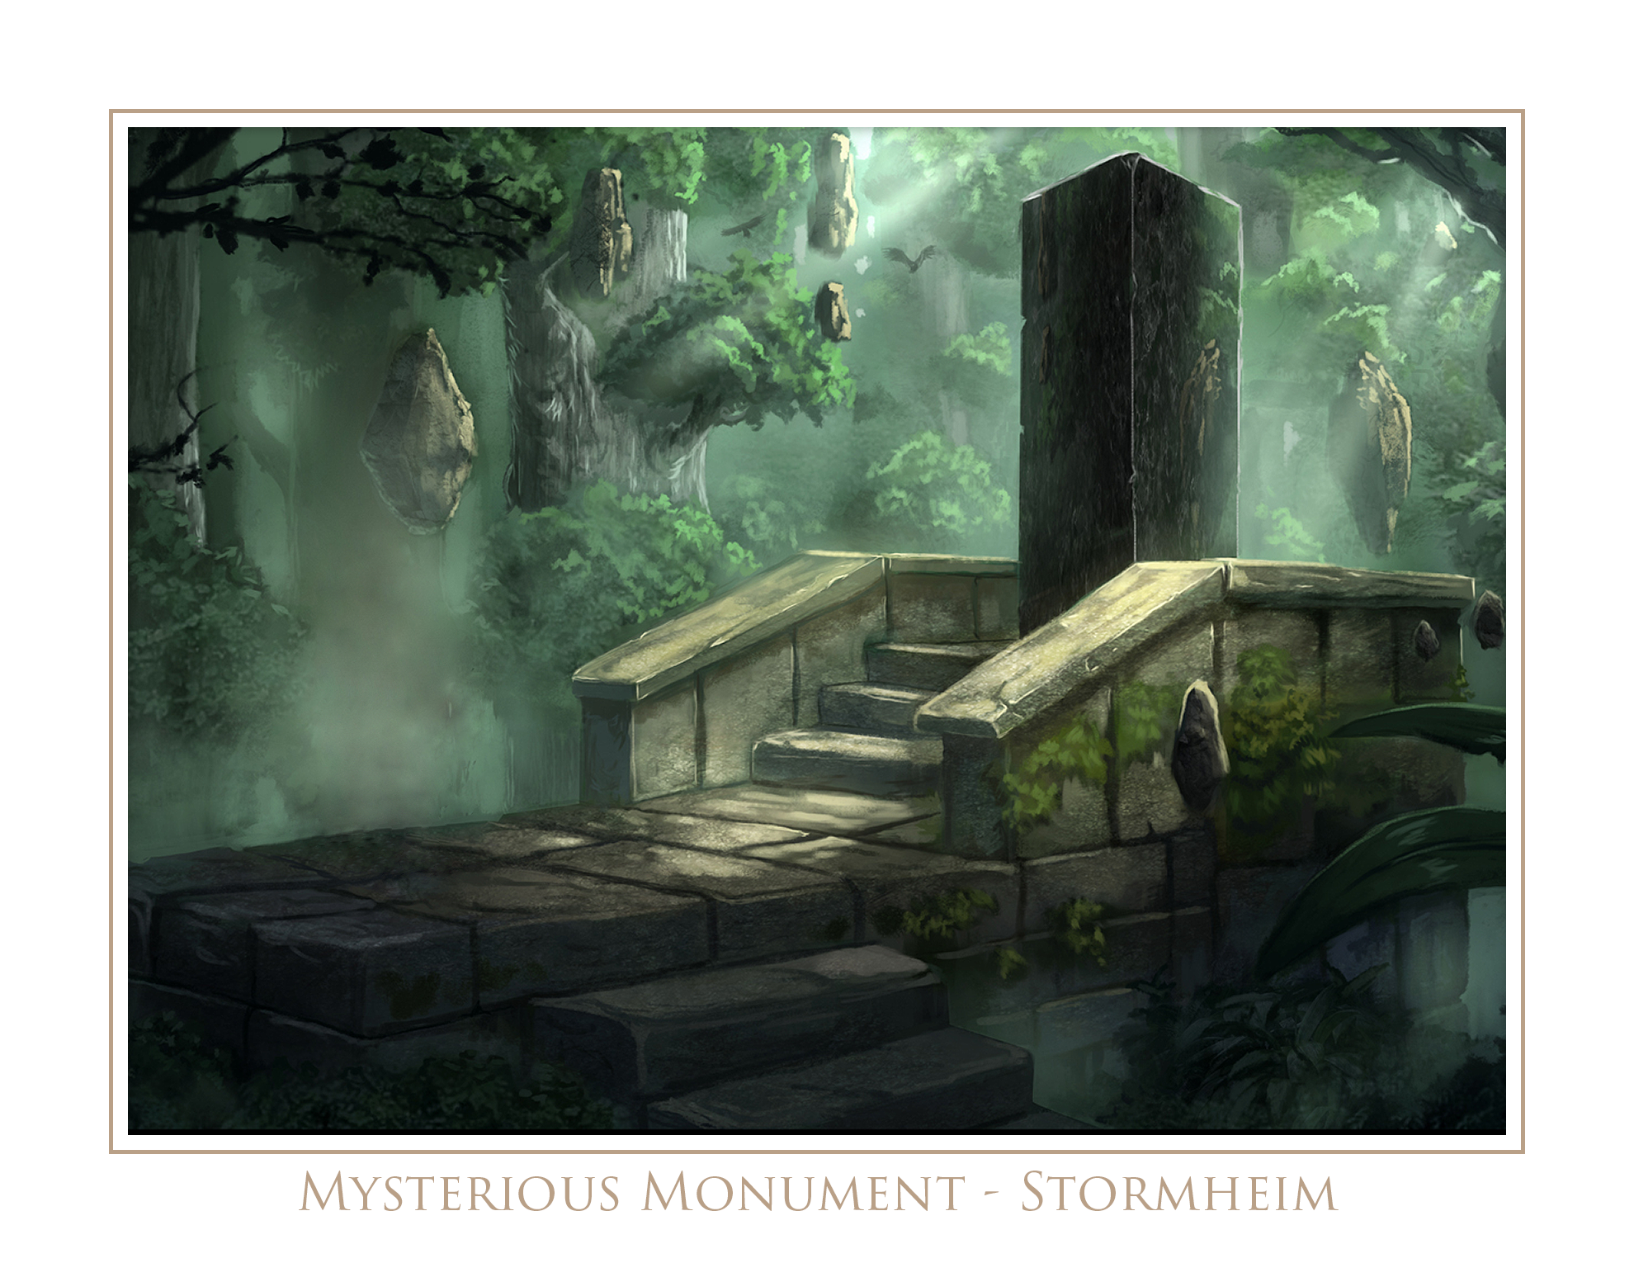

Stormheim - Giant

*“Halo of water, tongue of wood, skin of stone and long I’ve stood. My fingers short reach to the sky, inside my heart men live and die.” Solution: Castle*

◻ Opened ◻Conquered

**1. Tiny Room**

This room is small with stone walls and a floor, and can barely fit all of the party within it. There is an iron door that is locked. Engraved on it is a heart with lightning bolts coming out of it. There are also tigers or wild cats with human faces running below the heart.

The exiting door from the room has a lock that will require a key that is given to the party by Larak in the Aequanubi tribe, who enjoys sharing and collecting trinkets. His key has a heart insignia with lightning bolts coming out of it, like what is on the iron door. Larak’s key is tiny, and will need to be enlarged in ordered to be used on the door.

The door can be opened with Thieves’ tools on a DEX DC15 check, and can be broken down with a STR DC22 check.

**2. Golem Guardian**

The room contains a mechanical golem who becomes activated as soon as they step across the threshold. The golem is non-violent towards the party, and is more aggressive in an annoyed manner.

There is a key hanging from a string above one end of what looks to be a stone ramp. The players need to apply twice the force to the non-key end compared to the key end.

This key can then be inserted into the back of the mechanical golem that is trying to stop the party from getting the key. He will push players off the seesaw, apply its weight to the wrong end, and even knock over the many stone columns that are on the outside of the room.

Once the key is used to stop the golem it will drop to the floor and if the party inspects, they will see that inside is the key to the exit door.

**3. Direwolf Pit**

The entrance to the room is guarded by a yellow aura that rests on the threshold. It appears, sounds and even smells benign. As the party enters the room, a sudden rush of heat pours through your body and then it’s gone. You feel lighter. You find your equipment, weapons and armor are missing and transported to another location.

Upon entering the room the party is met with two ferocious looking torch braziers mounted to the left and right walls. The party will enter to a ledger that is 10’ wide and seems to descend into darkness. On the far side of the room appears to be a similarly sized ledge but there are no torches lit.

When the party inspects the room more closely they will find a rolled up piece of rope in the corner of the ledge platform wall that is about 12’. There is also an Immovable Rod next to it, along with a Ring of Spell Storing with an Invisibility to Animals spell in it.

When the party inspects the pit they will see 2 large dire wolves on the bottom angrily clawing at the wall, snapping their jaws towards the party. There also seems to be another Immovable Rod and another 12’ stretch of rope down there.

**4. Backwards Corridor**

The party enters into a corridor that looks normal but ends in a dead end with a stone wall. There is no light in the room. When the party reaches the dead end and turns around there is a brick wall, essentially trapping them inside the corridor. The new brick wall has an inscription that reads “*Keep your eye on the wall.”* If they walk backwards while staring at the brick wall they will walk into the next room.

**5. Giant’s Lair**

The room is tall at 30’ high, dark, with no torch braziers anywhere. It is nearly pitch black--this is important. They will stumble upon a small set of stairs leading up to a massive and heavy-duty, mithril vault in the middle of the room measured about 9 square feet and 7’ tall. The vault is sealed shut and is activated only by depressing two large recessed, stone circular switches that weigh 500 lb. each and sit on opposite sides of the room just beneath the ceiling. They measure about 10’ each as well. There are giant runes written on the round stone switch surfaces that say *“press here”.*

As soon as they enter the room, the door seals behind them and vanishes. They are now stuck in the room. In the room, along the north wall is a secret opening containing a medium sized box about 20 square inches wide, and 30 inches tall. WIS DC15 to find the secret opening, which is opened by just pressing on the area and it turns like a lazy-susan on a swivel. When the box is lifted out of its opening a trap will be activated DEX DC20 to prevent with Thieves’ tools, and will release a blind stone giant into the room from a mysterious alcove. The giant will stumble into a random direction and make a random action.

The box has a simple lid on the top, and the entire box has a silence spell cast upon it which can be detected. When the party opens the box they will be looking down onto themselves from the ceiling, and the ceiling will disappear as the lid. If no light is lit in the room however, the party will not see the ceiling above them be lifted, casting light upon the room. And as long as the silence spell is cast upon the box, they will not hear the ceiling be lifted.

By being a large giant themselves, the party can reach into the box and pull the giant into the room, which would cause him be super-tiny, the size of a mouse, or they can squish him.

The solution for the room is to reach into the box, depress both stone switches at the same time and the mithril vault will open revealing a piece of parchment paper, and written on it is a simple *“Great job!”* If they inspect the inside of the altar, WIS DC10 will reveal there is a false bottom, and underneath it are Bracers of Archery, Sword of Sharpness and a Ring of Feather Falling. The next portion of the map will be revealed to the party at this point.

✶

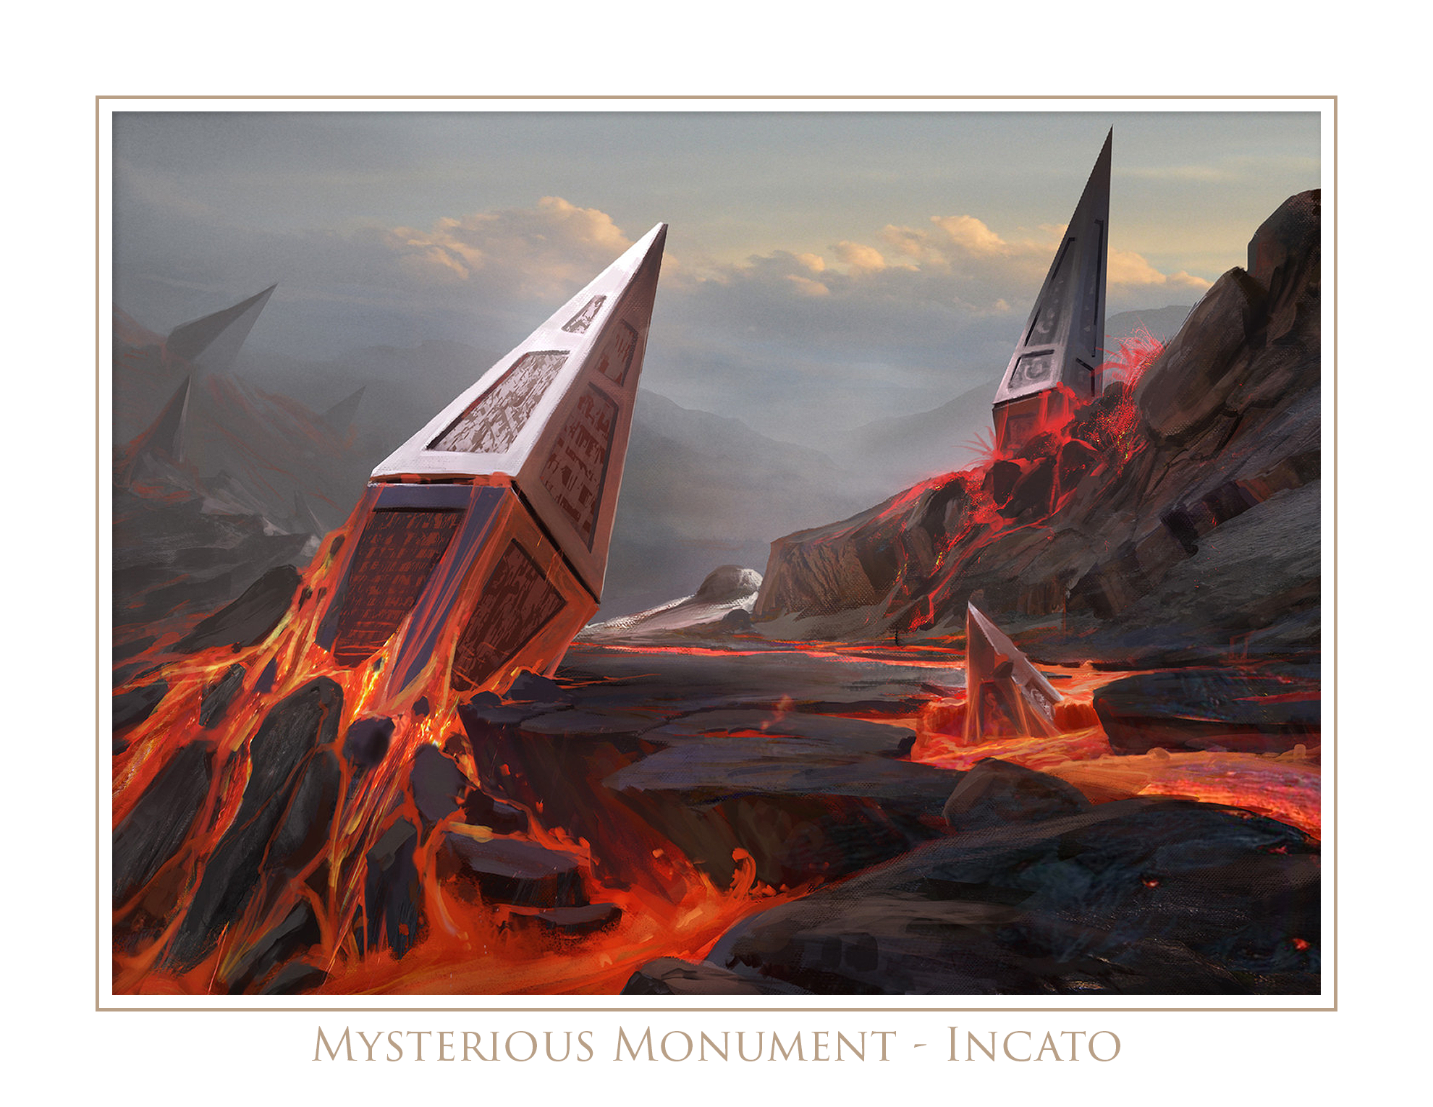

Incato - Sylvan

*“I shall ask, but never answer.” Solution: Owl*

◻ Opened ◻Conquered

**1. LIES**

The party enters the first room of the dungeon and it is small with 7 walls. There is a statue in the middle made of stone of a seven armed marilith holding 3 arms up in the air with their palms held upward. She also has 4 arms at her waist held outward with their palms upward as if to hold something. Engraved on her chest crudely, and with a sharp tool is the phrase *“GIVE ME MANY LIES, OR DIE”*

On the floor are seven circular tiles numbered 1-7 strewn about.

When the party puts the following numbers and in the correct order, 7135, in her bottom 4 hands, so that it looks like the word LIES, and then puts the rest of the numbers in any order in her top hands, her eyes will light up, then slowly fade out. At that point they’ll hear a knock on the door they came through. When they open it, it’ll be the next room.

If the party also has any dice that they place into the marilith’s hands, the door will open.

If the party guesses incorrectly however, a bolt of lightning damage will strike a random player requiring a DC10 DEX save, and upon fail, inflicting 8d6 damage.

**2. Sprite Garden Ring**

A tall circular room with lush moss and some foliage sticking out of stone walls. The floor is mostly grassy, particular in the middle, and there is a clear colorful ring of grass surrounding the middle of a violet color. On the opposite side of the room is a massive steel door, standing about 20’ tall. It has a large keyhole that requires what would appear to be a flat nosed key bearing many intricate teeths. If any of the party members cross the ring they will turn into a sprite and be confined to the ring.

The DM must pass a note to the player that says *“You do not believe you have changed into a sprite, and you cannot leave the ring, and must avoid telling the others that you cannot leave the ring. Your objective is to convince the others to join you in the middle of the ring.”*

When all the players are in sprite form in the middle of the ring, the violet grass ring will spread throughout the entire room and thus indicate they are free. The players can now fit through the keyhole and as soon as they do, they fall into their normal form on the other side.

**3. Boot Room**

The entrance to the room is guarded by a yellow aura that rests on the threshold. It appears, sounds and even smells benign. As you enter the room a sudden rush of heat pours through your body and then it’s gone. You feel lighter.

In this medium sized room there is a collection of boots on the ground in the middle, 8 to be exact, and they all look identical. The ground is sandy and dry on top of a stone floor that seamlessly becomes the walls and goes up to the ceiling about 10’ high where there is a trap door right in the center. This appears to be the only way out.

The room is being lit by two torches that are in beautifully crafted bronze braziers that look like owlbears.

When the party gets closer to the pile they see that there are several pieces of parchment mixed in with the boots. They have the following words written on them: MONONNOW, SONWIX, XINIZZIM and SOINWOS.

When the party member is wearing the correct pair of boots and says the correct command they will find the boots to be slightly glowing and activated with their magical properties, denoted below. The trick is for the party members to flip their pieces of paper over, as the words can be read both ways!

|  |  |  |  |
| --- | --- | --- | --- |
| Command | Left | Right | Type |
| MONONNOW | 5 | 4 | Speed |
| XIMNOS | 1 | 8 | Levitation |
| WIZZINIX | 7 | 2 | Springing |
| SOMNIOS | 3 | 6 | Winged |

The boots lose their magical properties once the party exits through the ceiling trap door.

**4. Seagrams’ Desires**

The party will enter into a small room that is pitch black except for the light coming through the trap door in the floor. All of the party’s equipment has returned to them in a pile about 10’ in front of them.

The trap door will suddenly close and two large torch braziers on both sides of a large iron door will erupt with flames, lighting the entire room. An iron sculpture of a unicorn’s head on the door will suddenly begin to speak.

*“Who dares to disturb my slumber! I am Seagrams, the unicorn and decide who may pass!”*

*“I only allow those who tell me their inner, truest most deepest and darkest desires pass through!”*

When the party tells Seagrams that they’d like to pass through the door, he will let them through. *Expect some pretentious and long-winded monologues!*

**5. Gems of War**

The party enters a large room where there is a column in the middle with 3 indentations for where gems go surrounding a large gem indentation. The gems are in the room in locations that would require each party member to use their specific talent/ability to dislodge/retrieve the gem for the column. When all gems are placed, the exit reveals itself as the stone wall seems to melt an entrance into view.

|  |
| --- |
| Amber: |
|  |
|  |
|  |
|  |

|  |
| --- |
| Teal: |
|  |
|  |
|  |
|  |

|  |
| --- |
| Pink: |
|  |
|  |
|  |
|  |

Upon completing the puzzle the exit door becomes unlocked and upon exit the party finds themselves through the front door of the dungeon, and the next portion of the map is revealed.

✶

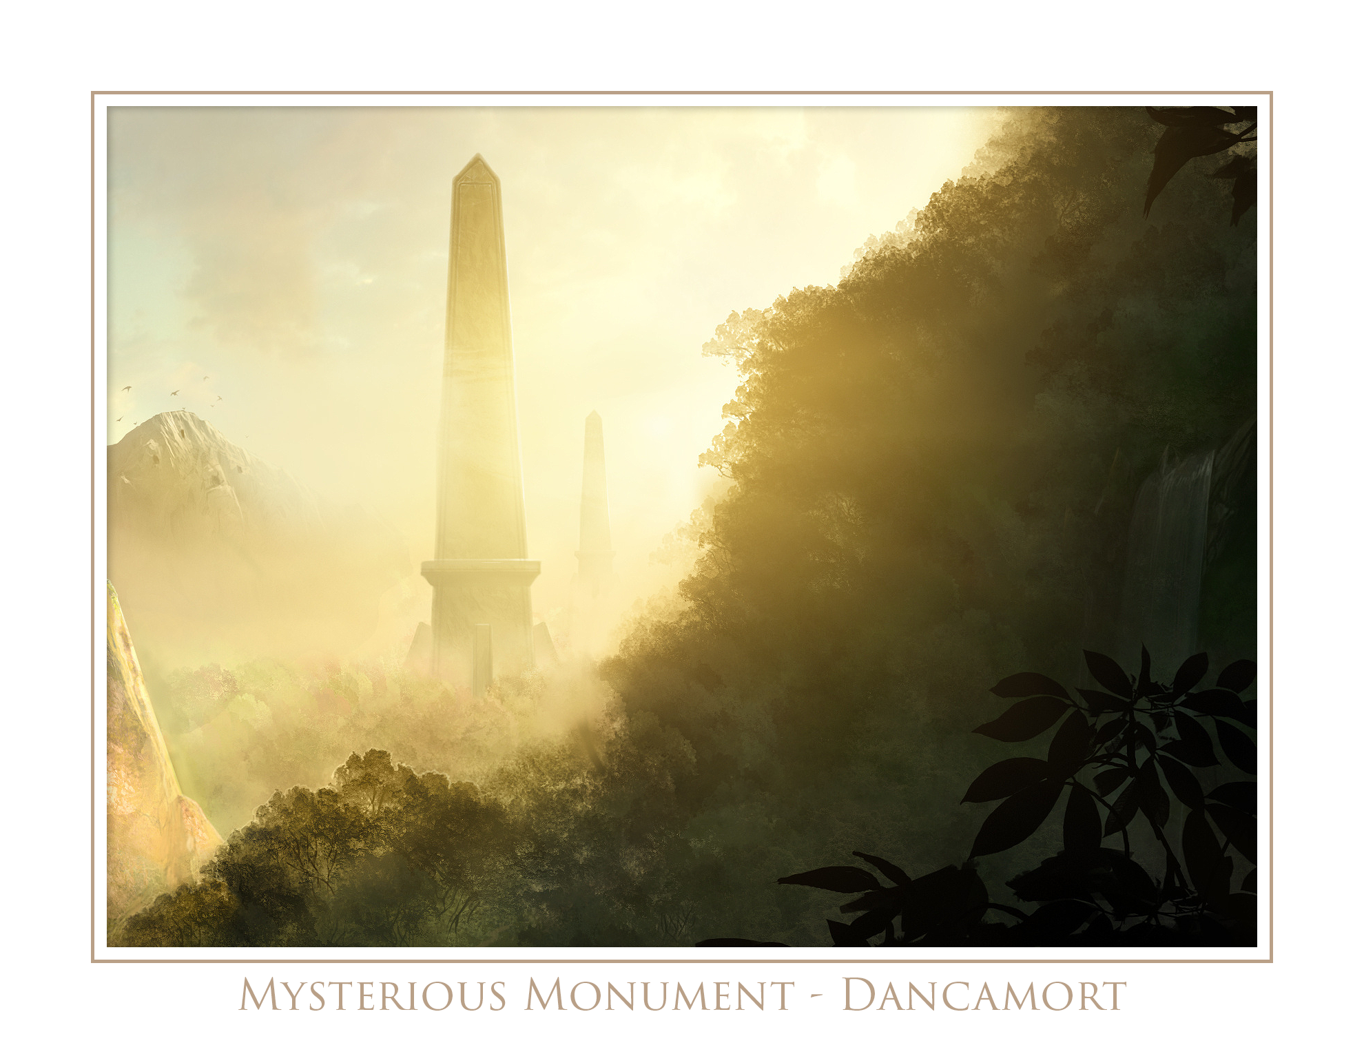

Dancamort - Celestial

*“The center of that which holds us here on this world.” Solution: V (graVity)*

◻ Opened ◻Conquered

**1. Entrance Room**

The party enters the first room and get caught in a tangle of webs that have grown over the threshold. It is dark, but dimly lit from mysterious sources of light, probably an eternal flame spell left long ago.

The room is large. It is 50 square feet and contains an assortment of things. There is an exit door made of flat and smooth iron on the other side with absolutely no lock or handle. The ceiling stands about 15’ high and is made of dark, black and strangely new-appearing paver stones that normally are found on the ground.

On the walls are several fountains, 6 to be exact, 3 on each side. Two appear to be working dribbling water over a thick patch of mold and algae into the bowls. The fountains are made of stone and have angels pouring pitchers as the source of water. In the middle of the floor traveling from the entrance door to the exit is a lightning-bolt shaped, shallow ditch that appears to have been strangely eroded by natural means. The ditch is filled with nothing but black mud and disgusting filth that has collected over who-knows how many years. The ditch is about 12” in width and 6” in depth.

Straddling this ditch is a statue of a one armed man holding what looks to be a sword over his head. The statue looks so old that the clothing on the figure has been worn down and he appears naked. On all four sides of the statue are levers affixed to a podium that the statue stands on.

Northern lever: Causes the water in the two working fountains to surge harder and produce a whistling noise somewhere deep in the dungeon.

Eastern lever: Causes the eyes of the statue to illuminate, and then it casts Silence on the room.

Southern lever: Causes all the players in the room to levitate off of the floor.

Western lever: Causes a stream of blood to pour from all the fountains out of their bowls, on to the floor.

If the party walks right by all of these objects and distractions in the room and merely pushes the exit door, it’ll swing right open.

**2. Alliteration**

The party exits the room and is now on a bridge that is dimly lit with candles on evenly spaced stands on the railing which seems to be protecting wanderers from falling into an infinite abyss. The bridge leads down a large 4-sided structure that seems to be floating in midair with nothing connected to its ceiling or floor. The bridge the party walks on seems to surround this structure completely. There are four doors on each side, and they are all unlocked. They are each painted a different color: White, blue, pink and silver.

When the party opens a door they’ll see a yellow aura that rests on the inside threshold, but they are not able to see within as there is a Darkness spell cast upon each entry. The aura itself sounds and even smells benign.

As a party member enters each room the door will close behind them, and on both sides the door will fade into the structure wall and entry/exit is now impossible. A sudden rush of heat will pour through their body and then it will be gone. They will feel lighter as their equipment is now all gone, transported to the next room. The party can now see the entire room on the inside, but they find themselves unable to speak as the room has Silence cast upon it.

The room is 35’ tall from floor to ceiling, and the platforms each player stands on is about 15’ high, right in the middle. The walls are smooth, and unscalable. On the floor is a gibbering mouther who is crawling and babbling about it seems, at a slug’s pace. On the ceiling is a small trap door.

|  |  |  |  |
| --- | --- | --- | --- |
| Ledge | Potion | Label | Extras |
| White | Water Walking | ALL | Immovable Rod |
| Blue | Blurring | ITE | 10’ rope |
| Silver | Spider Climbing | RAT |  |
| Pink | Poison | ION |  |

Throwing a vial: DEX DC10

Catching a vial: DEX DC10

Lip-reading: WIS DC15

When every party member is inside the room a voice will suddenly be heard in each player’s mind, explain the puzzle:

*“Safe travels young adventurers. Welcome to the Celestial dungeon. In this room your task is to ascend and escape through the small opening in the ceiling. You have undoubtedly realized that there is a spell upon this room of Silence. You will not be able to speak to one another. There are four potions on each of the ledges you stand on, along with two tools to assist you and test your wit. There is a white potion, a blue potion, a silver potion and a pink potion. Your possessions await you above in the next room. Player ( ) has an Immovable Rod on their ledge, and player ( ) has a 10’ piece of rope on their ledge. These are all the items here that you will be allowed to have for this puzzle. Be careful though, and do not hastily consume the potions. One is correct, two will only waste your time, and the remaining potion will kill you. The following are the potions: Water Walking, Blurring, Spider Climbing and Poison.”*

**3. The Curse**

The entrance room is circular with carved faces in the stone wall. They all seem to be holding their faces and covering their mouths. There is also a small trap door on the ceiling that looks like a small creature might fit inside. The door is locked. If broken, STR DC10, it will release two Will O’ Wisps. There is a faint torch mounted on the entrance and exit doors. In the middle arranged in a triangle are three stones of different colors, red, blue and yellow. If the party attempts to exit the room from the far door they’ll find it to be blocked by an invisible barrier. There is an inscription on the wall that reads:

*“At my feet lies three stones to hold dear. The source of three gifts that no one should bear. The keepers of secrets, the guardians of exits. Let the guessing begin, because shit’s gonna’ get hectic.”*

When a character picks up a stone it becomes affixed to his hands, and he is imbued with a curse per below. When the characters are able to identify any other character’s curse in a mostly general sense that is obvious, that curse is lifted and their particular barrier is lifted from the exit doorway.

* Red - Every sentence must begin and end with a word that begins with the letter M.
* Blue - When the player to your left speaks, clear your throat.
* Yellow - Replace all nouns with pronouns (He, she, it, we, they)

**4. Seasons**

The party enters an octagonal room with stone floors and ceiling. On the walls are the beautifully engraved depictions of common-life settings extended between two wall-facades, all with the same maiden wearing commoner’s clothing, in each scene:

* The maiden is walking in what appears to be a forest with nearly identically looking trees in the fore and background. All the tree limbs are bare. There is a bear standing against a tree, and it seems the maiden doesn’t see it. There is a large sun or moon in the sky hiding behind the trees.
* The same clothed maiden is swimming in what appears to be a pond, surrounded by mountains with a small treeline in the foreground, and under the water can be seen. There are several fish, snakes and many underwater plants. All of which have smiling human-like faces.
* The maiden is inside of a room kneeling at the front of a fireplace that is burning. There is a small four legged animal sleeping near her with a human-like face. There is a mantle above the fireplace opening with three numbers appearing to be resting *on* the mantle: 3, 5 and 9. There is a window to the left with circular drops of either snow or water falling.
* The last engraving is of the maiden standing on one of three gravestones, and reaching for what looks to be a wasp hive, or a crude, inaccurate representation of a honeybee hive, hanging from a tree branch that is full of leaves. On the ground is a plethora of wonderfully, and imaginatively shaped flowers that are growing in front of all the graves.

In the middle of the room is a crudely torn hole in the stone floor about 3’ wide. The floor appears to be about 12” deep before what looks to be fertile black earth resting at the bottom. (Buried in the dirt is a seed.)

The party will need to replicate each season in order, upon the dirt. As they correctly match each season with the corresponding action, the engravings on the wall will become colored like a painting and produce a very faint light. The human-like faces will become slightly animated with their eyes following one party member.

When all of the seasons are represented by an action upon the patch of dirt, a thick stalk of vines will rise from the ground and grow through the ceiling. It will sound and appear that that ceiling is very fragile, even eerily sounding of paper. The party can climb up the stalk into an abyss of darkness...

**5. Gems of War**

The stalk eventually leads to a platform, floating in the darkness. There is what looks to be ash or snow falling lightly in the air. The platform has moss growing with several rocks and small boulders scattered about. It seems like the party and this platform have been cut out of a ruined bluff in the Silent Plains. Ahead, 30’ along a stony path is an eroded doorway that is being held up by the remnants of a structure long gone. The party is smart enough to see that the markings of the burn marks on this doorway are that of dragon’s fire. The platform seems to continue past this doorway and then just ends. It does not appear that there is any other way to go except back down the stalk.

When the party opens the door they will see the next room. Once they pass into the room, the door behind them will close. Opening it will only reveal a stone wall.

In the large room there is a column in the middle with 3 indentations for where gems go surrounding a large gem indentation. The gems are in the room in locations that would require each party member to use their specific talent/ability to dislodge/retrieve the gem for the column. When all gems are placed, the exit reveals itself as the stone wall seems to melt an entrance into view.

|  |
| --- |
| Cyan: |
|  |
|  |
|  |
|  |

|  |
| --- |
| Black: |
|  |
|  |
|  |
|  |

|  |
| --- |
| Gold: |
|  |
|  |
|  |
|  |

Upon completing the puzzle the exit door becomes unlocked and upon exit the party finds themselves through the front door of the dungeon, and the next portion of the map is revealed.